**Ministry of Water Resources**

Bangladesh Water Development Board

Coastal Embankment Improvement Project, Phase-I (CEIP-I)

**Long Term Monitoring, Research and Analysis of Bangladesh Coastal Zone (Sustainable Polders Adapted to Coastal Dynamics)**

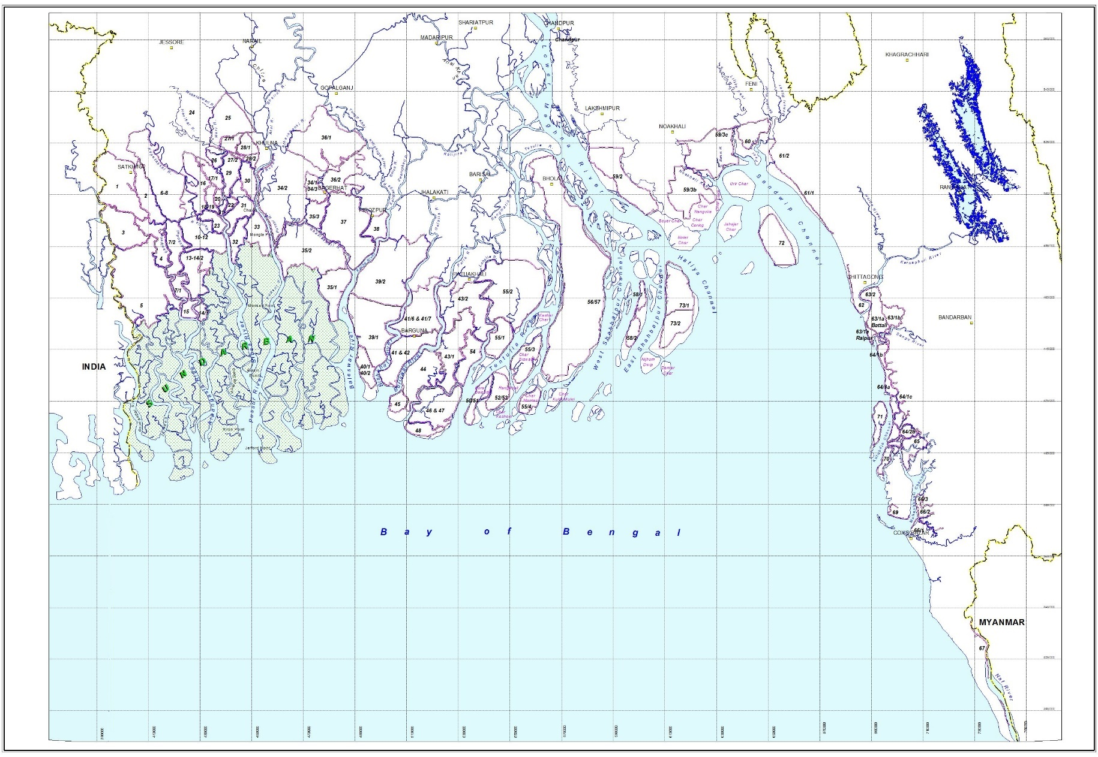

|  |  |  |
| --- | --- | --- |
|  |  |  |

**Quarterly Progress REPORT-7**

September 2020



**Ministry of Water Resources**

Bangladesh Water Development Board

Coastal Embankment Improvement Project, Phase-I (CEIP-I)

**Long Term Monitoring, Research and Analysis of Bangladesh Coastal Zone (Sustainable Polders Adapted to Coastal Dynamics)**

**Quarterly Progress REPORT-7**

September 2020



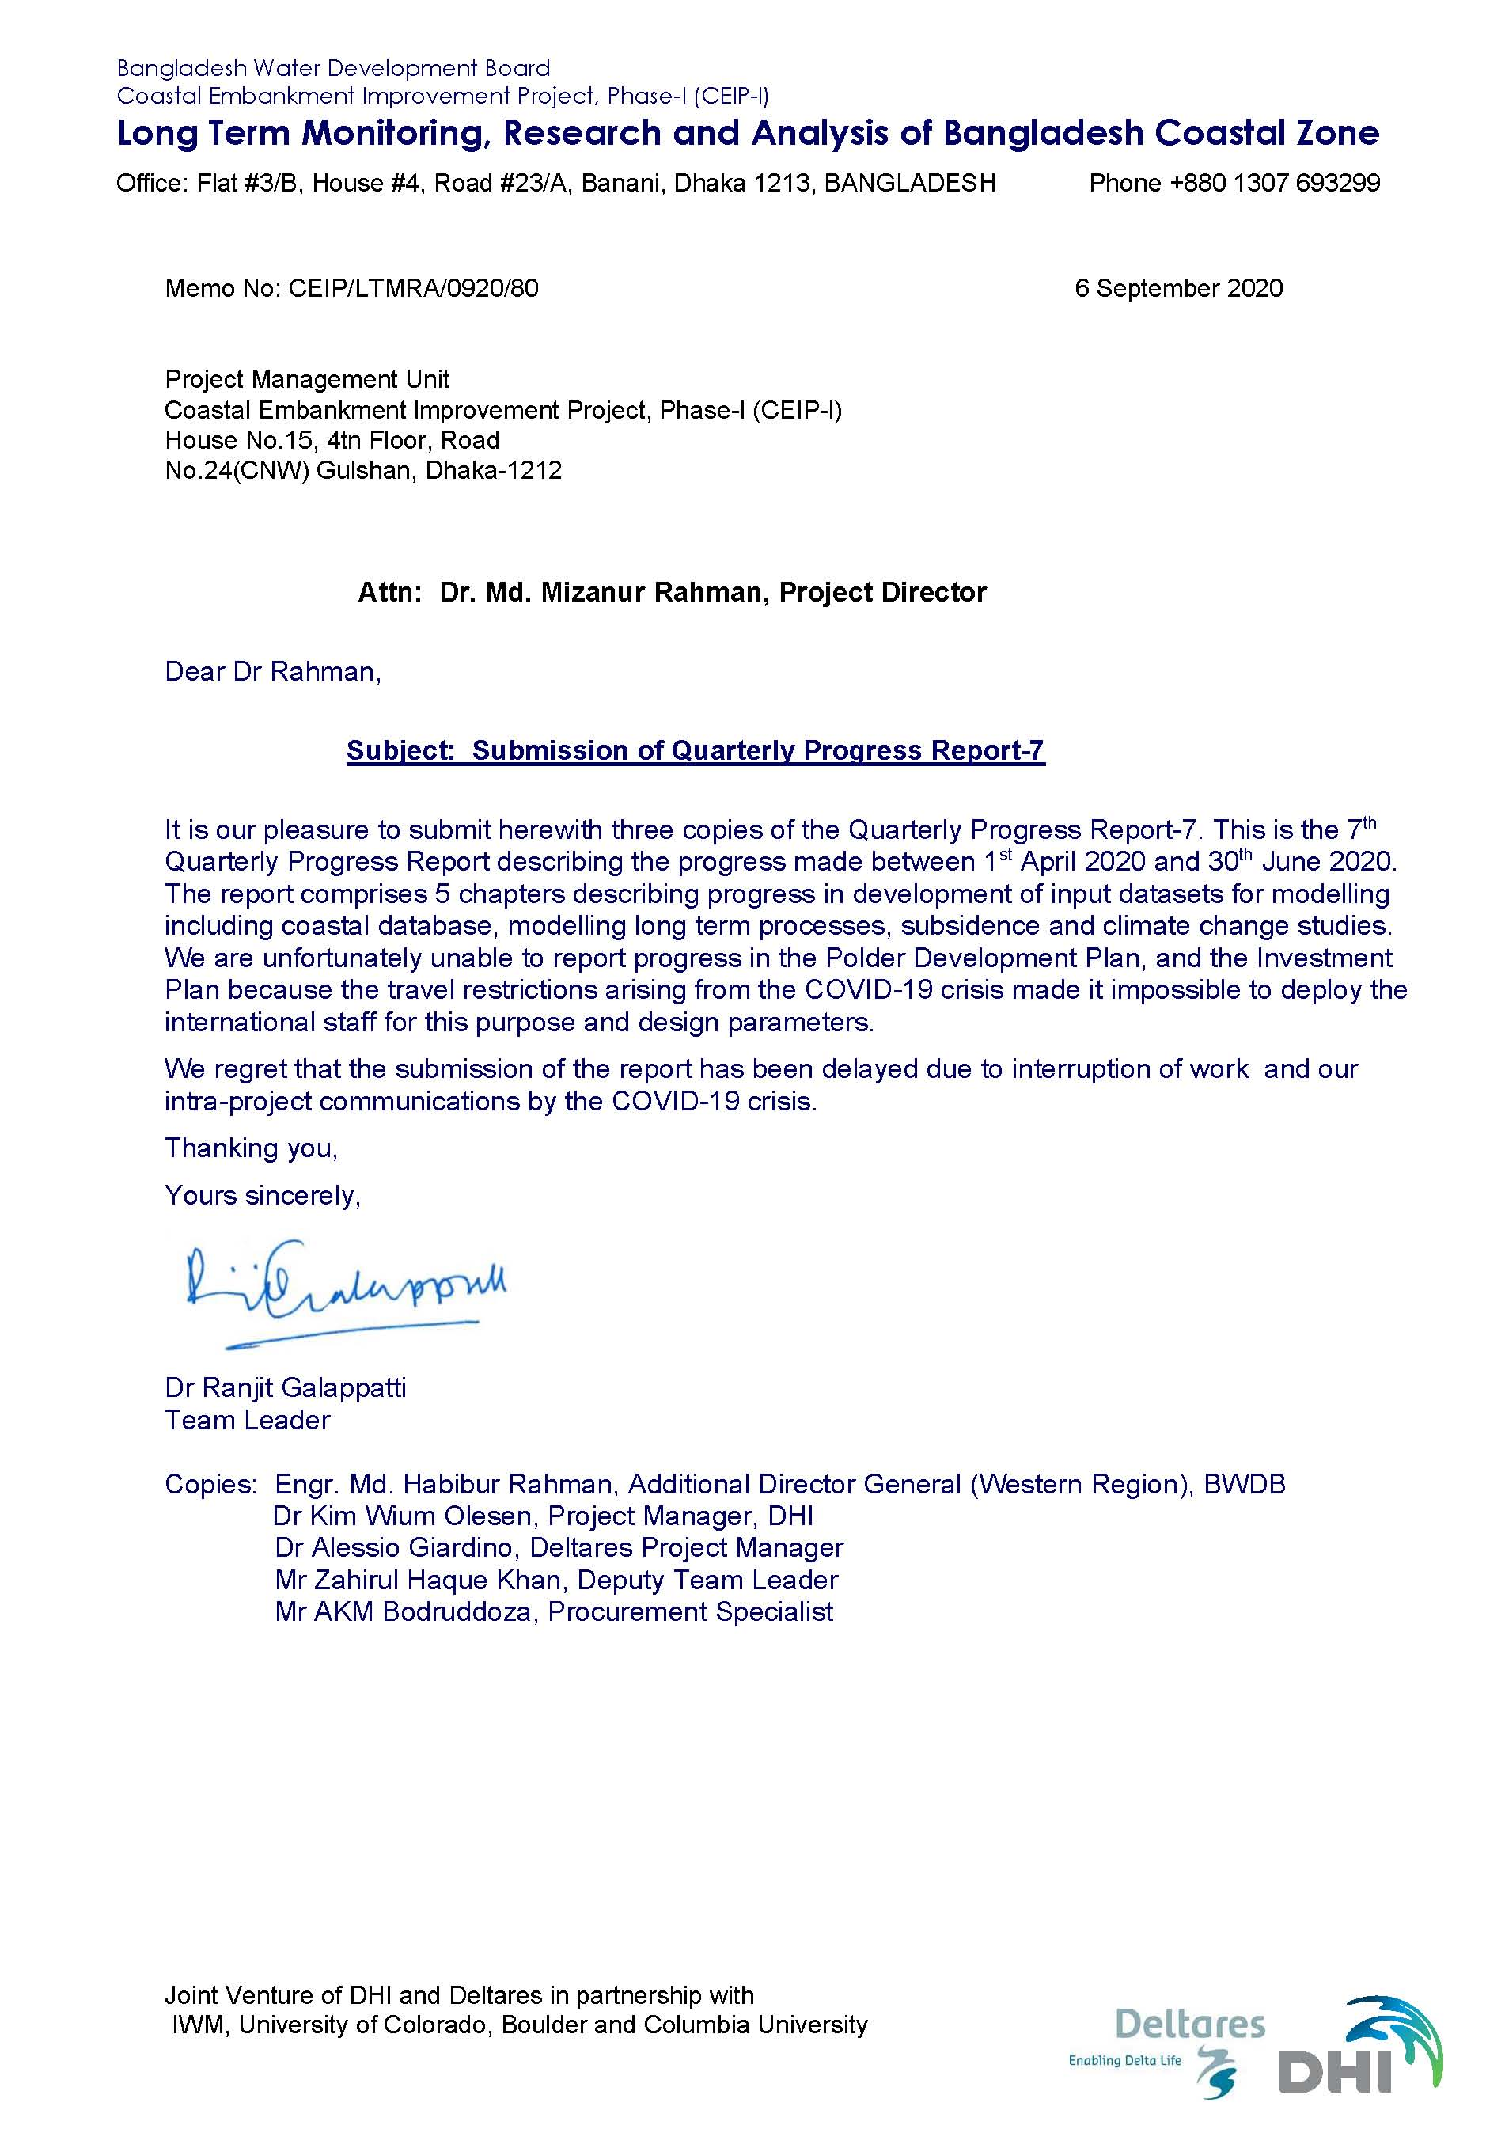

Contents

1 INTRODUCTION 13

1.1 Work Plan 13

1.2 List of Non-Modelling Milestones and Deliverables (pl see Chapter 4 for Modelling Deliverables) 19

1.3 Components 1, 2 and 3 25

2 DEVELOPMENT OF INPUT DATASETS FOR MODELLING PHYSICAL PROCESSSES 27

2.1 Collecting Existing Data 27

2.2 Field Surveys carried out by IWM 27

2.2.1 Mobilization 27

2.2.2 Summary of Field Survey Activities in the 7th Quarter (ending 30 June 2020) 27

3 DEVELOPMENT OF INTERACTIVE GEODATABASE OF COASTAL ZONE 35

3.1 Introduction 35

3.2 Data Collection and Data Processing 36

3.3 Satellite Image Processing 36

3.4 Web GIS Application Development 40

3.4.1 Work Plan 41

3.5 Plan for Next Quarter 41

3.6 Sample Screenshots from Application 42

3.7 User Access and Training 45

4 MODELLING LONG TERM PROCESSESS 47

4.1 Introduction 47

4.2 Macro Scale Models: GBM Basin wide Applications 48

4.2.1 The Hydrotrend model 49

4.2.2 Macro Scale Models: 2D Model of Large Rivers and Coastal System 50

4.2.3 Macro Scale Models: 1D Model of Large Rivers System 51

4.3 Meso Scale Models for Long Term Morphology 54

4.3.1 Pussur-Sibsa River system for meso scale modelling for long term morphology 55

4.3.2 Pussur-Sibsa River system for meso scale modelling for fine sediment 56

4.3.3 Plume Model for Fine Sediment Pathways 56

4.3.4 Baleswar-Bishkhali River system for meso scale modelling for long term morphology 57

4.3.5 Lower Meghna Estuary for meso scale modelling for long term morphology 57

4.3.6 Sangu River system for meso scale modelling for long term morphology 58

4.4 Meso Scale Models for Bank Erosion 58

4.4.1 Introduction 59

4.4.2 Modelling template 60

4.4.3 Flow resistance and 3D flows in the riverbends 62

4.4.4 Bed forms 64

4.4.5 Sand-silt interaction 64

4.4.6 Bank erosion 64

4.4.7 Overview of the four finalized models 69

4.4.8 References 71

4.5 Morphological Models for TRM (Micro Scale) 72

4.5.1 Pilot Tidal River Management (TRM) model for Polder 24 73

5 OTHER STUDIES 79

5.1 Subsidence and Delta Building 79

5.2 Climate Change Effects (analysis of historical data) 79

5.2.1 Rainfall 79

5.2.2 Temperature 82

5.2.3 Tropical cyclones 87

5.3 References 91

6 POLDER RECONSTRUCTION PROGRAMME 93

6.1 Background 93

6.2 Selection of 3-5 Polders for Pilot Study 96

6.3 Strategic Approach towards devising a Polder Reconstruction Programme 97

6.4 Investment Plan for the Entire CEIP 99

7 DESIGN PARAMETERS, CONSTRUCTION MANAGEMENT & MONITORING 101

FIGURES

Figure 3.1 Coastal Area shows on District Boundaries 37

Figure 3.2 Morphological changes in rivers bank lines of coastal area 38

Figure 3.3 Sample map of the morphological changes during 2015-2020 in a part of the coastal area. 39

Figure 3.4 Work Plan 41

Figure 3.5 Application Login Page 42

Figure 3.6 Application Dashboard 43

Figure 3.7 Web GIS Core Module 43

Figure 3.8 Sample Hydrograph of Surface Water Level Time Series Data 44

Figure 3.9 Sample Map output from Application 44

Figure 3.10 Document Archive Page 45

Figure 4.1 Map showing the Ganges and Brahmaputra basins 49

Figure 4.2 Yearly cumulative mud transports (left pane) and sand transports (right pane) in macro scale model, mind the different vector scales 51

Figure 4.3 Simulated bed level changes, 2000-2019 51

Figure 4.4 River network for the Delft3D-FM 1D model. 52

Figure 4.5 Maps showing the selected measured cross sections imposed on the model. 53

Figure 4.6 Map of meso scale modelling groups for long term morphology 55

Figure 4.7 Sedimentation/erosion pattern after 9 years (2011 to 2019), measured (left panel) and modelled (right panel) 56

Figure 4.8 Yearly cumulative mud transports, details of Figure 4.2 (mind the different vector scales). Left panels are for mud. Top panels are with waves and wind. Lower panels are without waves and wind 57

Figure 4.9 Observed (left panel) and simulated (right panel) bed level changes, 2000-2009, settings 2 58

Figure 4.10 The four finalized MIKE 21C models, from west: Sibsa, Pussur, Baleswar, Bishkhali. 60

Figure 4.11 Curvilinear grid for the Bishkhali model, 800x15 grid points 61

Figure 4.12 Bishkhali River model bathymetry based on the 2019 bathymetry data contoured to the 2019 grid. 62

Figure 4.13 Local model covering the sharpest bends (268x30 grid cells) in Bishkhali River. This model was used for investigating the impact of flow resistance and 3D effects on the velocity profiles. 63

Figure 4.14 Application of the van Rijn regime predictor for the point bars in Pussur River. 64

Figure 4.15 Illustration of the differences between the 2011 and 2019 grids, which cannot be identified without looking at the details. This is Baleswar, just upstream of the Gashiakali inflow where the eastern bank has been eroding consistently. The 2019 grid conforms to the 2019 bank line, as seen in the figure. The bank line moved roughly 100 m from 2011 to 2019. 65

Figure 4.16 Bank line changes based on Landsat in the sharpest bend of Bishkhali River in the period 1988-2019. The bank lines show very systematic and relatively slow erosion (typically up to 10-20 m/year, and Bishkhali has the highest erosion rate of the four rivers studied thus far; not that Lower Meghna will change that). Bank accretion can also be observed, but this is not modelled, except as a passive process in which deposition will take place in the riverbed. The observed bank lines for Bishkhali exhibit textbook behavior. 66

Figure 4.17 Observed bank erosion as function of chainage in Bishkhali River 2011-2019 for the east and west banks. The 2019 bed levels along the banks are shown as well to illustrate the strong correlation between bed levels and bank erosion, which we also see for Sibsa, Pussur and Baleswar. Note: We do not have a 2011 bathymetry for Bishkhali. 68

Figure 4.18 Observed and simulated bank erosion 2011-2019 comparison along the east and west bank of Bishkhali River. 69

Figure 4.19 River Network for Mike 11 Model Extracted from SWRM 73

Figure 4.20 Bed level development after activation of TRM at the southern end of the polder in the consecutive period of 6 years. 74

Figure 4.21 Bed level changes after activation of TRM at the southern end of the polder in the consecutive period of 6 years. 75

Figure 4.22 Annual bed level changes after activation of TRM at the southern end of the polder in the consecutive 6 years. 76

Figure 4.23 Area inside polder above a certain bed level during TRM operation. 77

Figure 4.24 Area inside Hari River branch above a certain bed level during TRM operation. 77

Figure 5.1 Rainfall stations (32 in total) for which data was available to this project. 79

Figure 5.2 Data availability for the 32 rainfall stations. Gaps in the line indicate missing data. 80

Figure 5.3 Annual average rainfall: comparison between results from Shahid et al [2011] (left) and this report (right). 81

Figure 5.4 Trends in annual total rainfall: comparison between the results from Shahid (2009) (left) and this report (right). 81

Figure 5.5 Temperature stations (34 in total) for which data was available to this project. 83

Figure 5.6 Data availability for the 34 temperature stations. Gaps in the line indicate missing data. 85

Figure 5.7 Annual average temperature: comparison between MOEF [2005] (left) and the results from our analyses (right). 85

Figure 5.8 Trends in annual mean temperature; Mann-Kendal test. 86

Figure 5.9 Historical tropical cyclone tracks since 1972 as reported in the JTWC database. Indication of the wind speed and severity is provided according to the classification by the India Meteorological Department (IMD) for the North Indian Ocean. 88

Figure 5.10 Probabilities of genesis (a) and termination (b) for historical tropical cyclones since 1972. Data retrieved from the JTWC database. 88

Figure 5.11 Yearly probability of historical TC since 1972. Data retrieved from the JTWC database. 89

Figure 5.12 Monthly probability of TC generation in the Bay of Bengal based on historical cyclones since 1972. Data retrieved from the JTWC database. 89

Figure 5.13 Number of cyclones per year since 1972 as retrieved from the JTWC database for: (a) the North Indian Ocean, (b) the Bay of Bengal and (c) the Bangladesh coastal zone. Plots are made for all cyclones (in blue) and only the severe cyclones (maximum wind speed larger than 40 m/s) (in orange). Linear trend lines have been added to show estimated changes in cyclone frequency over the time period. 90

Figure 5.14 Boundaries of the three regions: North Indian Ocean, Bay of Bengal and Bangladesh. 91

TABLES

Table 1.1 Original Activity Schedule Page 1 15

Table 1.2 List of non-modelling milestones and deliverables 19

Table 1.3 Deliverable related to Modelling activities 20

Table 2.1 Progress of survey for the 5 polders 29

Table 2.2 Progress discharge observation 30

Table 2.3 Progress of suspended sediment sampling for total concentration 31

Table 2.4 Progress of suspended sediment and bed sampling for grain size distribution 31

Table 2.5 Progress of water level data collection 32

Table 2.6 Progress of Salinity Data Collection 33

Table 2.7 Progress of Monitoring Section 34

Table 3.1 Statistical information on the morphological changes of rivers in the coastal area 38

Table 4.1 Models currently under development 47

Table 4.2 Macro Scale Modelling 48

Table 4.3 Meso Scale Modelling for Long Term Morphology 54

Table 4.4 Meso Scale Modelling for Bank Erosion Prediction 58

Table 4.5 Parameters for the four finalized models 70

Table 4.6 Morphological Modelling on Micro-scale 72

Table 5.1 Names and coordinates of the 32 rainfall stations of Figure 5.1. 80

Table 5.2 Derived trend classes for rainfall for the combination of all stations. Results are shown for two indicators, four statistical tests and five different seasons (including the whole year). 82

Table 5.3 Names and coordinates of the 34 rainfall stations of Figure 5.5. 84

Table 5.4 Derived trend classes for temperature the combination of all stations. Results are shown for three indicators, four statistical tests and five different seasons (including the whole year). 87

Table 6.1 Five Polders Selected for Pilot Design Study 96

Table 6.2 Indicators for Polder Data Description 98

**ACRONYMS AND ABBREVIATIONS**

ADCP- Acoustic Doppler Current Profiler

BDP2100- Bangladesh Delta Plan 2100

BIWTA- Bangladesh Inland Water Transport Authority

BMD- Bangladesh Meteorological Department

BoB- Bay of Bengal

BWDB- Bangladesh Water Development Board

CBA- Coast Benefit Analysis

CCP- Chittagong Coastal Plain

CDMP-Comprehensive Disaster Management Program

CDSP- Char Development Settlement Project

CEA- Cost Effectiveness Analysis

CEGIS- Centre for Environmental and Geographic Information Services

CEIP- Coastal Embankment Improvement Project

CEP- Coastal Embankment Project

CERP-Coastal Embankment Rehabilitation Project

CPA- Chittagong Port Authority

CPP-Cyclone Protection Project

CSPS-Cyclone Shelter Preparatory Study

DDM- Department of Disaster Management

DEM- Digital Elevation Model

DOE- Department of Environment

EDP- Estuary Development Program

FAP- Flood Action Plan

FM- Flexible Mesh

GBM- Ganges Brahmaputra Meghna

GCM- General Circulation Model

GIS- Geographical Information System

GTPE- Ganges Tidal Plain East

GTPW- Ganges Tidal Plain West

HD- Hydrodynamic

InSAR- Interferometric Synthetic Aperture Radar

IPCC- Intergovernmental Panel for Climate Change

IPSWAM- Integrated Planning for Sustainable Water Management

IWM- Institute of Water Modelling

LCC- Life Cycle Costs

LGED- Local Government Engineering Department

LGI- local Government Institute

LRP- Land Reclamation Project

MCA- Multi Criteria Analysis

MES- Meghna Estuary Study

MoWR- Ministry of Water Resources

MPA- Mongla Port Authority

NAM - Nedbor Afstromnings Model

PPMM- Participatory Polder Management Model

RCP- Representative Concentration Pathways

RTK- Real-Time Kinematic

SET-MH- Surface Elevation Tables – Marker Horizons

SLR- Sea Level Rise

SOB- Survey of Bangladesh

SSC- Suspended Sediment Concentration

SWRM- South West Region Model

TBM- Temporary Bench Mark

ToR- Terms of Reference

WARPO- Water Resources Planning Organization

WL - Water Level

# INTRODUCTION

The coastal zone of Bangladesh spans over 710 km of coastline and is subject to multiple threats. Sixty- two percent of the coastal land has an elevation less than 3 meters above mean see level. The coastal lands, being subject to regular flooding by saline water during high tides, could not be used for normal agricultural production in a country with a very high demand for land. The Coastal Embankment Project (CEP) was initiated in the 1950s and 1960s to build polders surrounded by embankments preventing the spilling of saline water onto the land at high tides. These embankments were built along the larger rivers and across the smaller rivers and creeks which then formed the drainage system within each polder and connected to the peripheral rivers via appropriately sized flap gate regulators, that open at low tide to let the drainage water out.

The Coastal Embankment Project made possible the reclamation of large tracts of land for agriculture from 1960 onwards. Polder building proceeded continuously until today. We now have 1.2 million hectares reclaimed in 139 active polders in the coastal zone of Bangladesh.

In over half century of its existence, a number of challenges have surfaced threatening the long-term safety and even the very existence of the polder system as a viable and sustainable resource. These are:

* The interference with natural tidal regime created severe siltation problems in some rivers resulting in severe drainage congestion in some polders.
* Sea level rise and changes in precipitation and water discharge due to climate change
* Threats of damming and diversion to the delivery of river sediments from upstream
* Subsidence of lands (except where it has been allowed to be rebuilt by tidal flooding) and structures founded on existing land
* Increasing vulnerability to cyclones and storm surges

The damage caused by Cyclones Sidr and Aila in 2007 and 2009 led to a major new investment of World Bank funds called the Coastal Embankment Improvement Project through which the coastal embankment system was to be improved and made much more climate resilient, over several phases of construction. After the feasibility study of the first phase CEIP-1, it was recommended that certain gaps in our knowledge of the delta should be addressed by the research study which was to be known as the **Long-Term Monitoring, Research and Analysis of Bangladesh Coastal Zone.**

After a very long gestation period, the study was initiated on 15 October 2018 and the Inception Phase was completed in January 2019. The Inception Report was treated as the first Quarterly Progress Report (QPR-1). The Second Quarterly Progress Report which was submitted in April 2019 covered the period 1 January 2019 to 31 March 2019. The Third Quarterly Progress Report (QPR-3) covers the period 1 April 2019 to 30 June 2019. QPR-4 covered the period from 1 July 2019 to 30 September 2019. QPR-5 covering the period 1 October 2019 to 31 December 2019 was submitted in February 2020. QPR-6 covered period 1 January to 31 March 2020. This is the Seventh Quarterly Progress Report describing the progress made between 1st April to 30th June 2020.

## Work Plan

The Inception Report (DHI, 2019) gave a detailed description of the work to be carried out by this project. Table 1.1 shows the full schedule of activities to be carried out during the 30 months of the project. This work plan in based on the plan shown in the Inception Report published in December 2018. This work plan is a more detailed version with some adjustments have that have had to be made due to contingencies and developments in the field. The updated work plan applicable for the 5th Quarter, which still includes the original deliverables as well as additional outputs, as re-scheduled in January 2020 was shown in Table 1.2 of QPR-6.

The advent of the COVID pandemic early in the year has disrupted the work especially because of the travel restrictions placed on international staff by their respective governments from March 2020 onwards. The work plan and the staff deployment plan has been under continuous negotiation throughout the last quarter. These negotiations proceeded throughout this quarter and have reached a conclusion at the meeting with the BWDB and the World Bank on 17 August 2020.

Table 1.1 Original Activity Schedule Page 1



Table 1.1 (contd) Original Activity Schedule Page 2



Table 1.1 (contd) Original Activity Schedule Page 3



Table 1.1 (contd) Original Activity Schedule Page 4



Draft submission of report Revised submission of report

## List of Non-Modelling Milestones and Deliverables (pl see Chapter 4 for Modelling Deliverables)

Table 1.2 List of non-modelling milestones and deliverables



Table 1.3 Deliverable related to Modelling activities

| **TOR Reference** | **TOR Deliverables** | **Scale** | **Model** | **Description each** |  |  | **Delivery Dates** |
| --- | --- | --- | --- | --- | --- | --- | --- |
| D-4A-1: 1 | The software newly developed under this project with all source code and accompanying technical document with detailed explanation of the methodology and assumptions |  | Instead of Source Code the Consultant will deliver the following for every model set up and run under this project: a) The Model Set up files and related report b) Input data files and related results files c) Related software licences tranferred to BWDB | | | |  |
| D-4A-1: 2 | Geospatial datasets of main sources and deposits of sediment at present, including full meta-data a restored and archived in Database of BWDB  Geospatial datasets of main sources and deposits of sediment for 100 years from present, including full meta-data are published and archived in Database of BWDB. | **Macro** | GBM Basin Model | Model Set up Calibration & Validation | **a** | D4A-1 Describes all these activities . Deliverable between Aug 19 and Oct 20 | Feb-21 |
| **Macro** | Macro scale River Model | Model Set up Calibration & Validation | **a** | Feb-21 |
| **Macro** | Macro scale River Model | Model Set up Calibration & Validation | **a** | Feb-21 |
| **Macro** | GBM Basin Model Applications | Climate Change Simulations | **b** | Feb-21 |
| **Macro** | Macro scale River Model Applications | Climate Change Simulations | **b** | Feb-21 |
| **Macro** | Macro scale River Model Applications | Climate Change Simulations | **b** | Feb-21 |
| **Macro** | Sediment Budget Analyses | Long Term Sediment Balances in Delta |  | Feb-21 |
| D-4A-1: 3, 4 | Geospatial datasets of main sources and deposits of sediment for 100 years from present, including full meta-data are published and archived in Database of BWDB. Technical reports |  | **FINAL REPORT ON MORPHOLOGICAL TRENDS** | | **A** | Oct-20 |
|  | **SPECIAL REPORT ON SEDIMENT RECIRCULATION IN THE DELTA** | | **B** | Oct-20 |
|  |  |  |  |  |  |  |  |
|  |  |  | **Long Term Morphology Modelling** |  |  |  |  |
| D-4A-2: 1, 2 | Report on upgrade and update of present meso scale model including detailed explanation of the methodology and assumptions. Geospatial datasets of erosion and sedimentation in the coastal zone at present for various seasons and circumstances in relevant. These geospatial datasets should include full meta-data and be stored and archived in Database of BWDB | **Meso** | Pussur Sibsa | Model Set up Calibration & Validation | **a** |  | Nov-20 |
| **Meso** | Baleswar-Bishkhali Model | Model Set up Calibration & Validation | **a** | Nov-20 |
| **Meso** | Lower Meghna | Model Set up Calibration & Validation | **a** | Nov-20 |
| **Meso** | Sangu | Model Set up Calibration & Validation | **a** | Nov-20 |
| D-4A-2: 3 | Geospatial datasets of erosion and sedimentation in the coastal zone for possible scenarios 25, 50 and 100 years from now, for various reasons and circumstances if relevant. These geosparial datasets should incldue full meta-data and be stored and archived in Database of BWDB | **Meso** | Pussur Sibsa | Long Term Morphology Applications | **b** |  | Feb-21 |
| **Meso** | Baleswar-Bishkhali Model | Long Term Morphology Applications | **b** | Feb-21 |
| **Meso** | Lower Meghna | Long Term Morphology Applications | **b** | Feb-21 |
| **Meso** | Sangu | Long Term Morphology Applications | **b** | Feb-21 |
| D-4A-2: 4 | Technical report (one report for 4A-1 and 4A-2) |  | **FINAL REPORT ON ESTUARINE MORPHOLOGY** | | **C** |  | Nov-20 |
|  |  |  |  |  |  |  |  |
|  |  |  | **Bank Erosion on Meso Scale** |  |  |  |  |
| D-4A-2: 1, 2 | Report on upgrade and update of present meso scale model including detailed explanation of the methodology and assumptions. Geospatial datasets of erosion and sedimentation in the coastal zone at present for various seasons and circumstances in relevant. These geospatial datasets should include full meta-data and be stored and archived in Database of BWDB | **Meso** | Pussur | Model Set up Calibration & Validation | **a** |  | Jun-20 |
| **Meso** | Sibsa | Model Set up Calibration & Validation | **a** | Jun-20 |
| **Meso** | Baleswar | Model Set up Calibration & Validation | **a** | Jun20 |
| **Meso** | Bishkali | Model Set up Calibration & Validation | **a** | Jun-20 |
| **Meso** | Lower Meghna | Model Set up Calibration & Validation | **a** | Jun-20 |
| **Meso** | Sangu | Model Set up Calibration & Validation | **a** | Jun-20 |
| D-4A-2: 3 | Geospatial datasets of erosion and sedimentation in the coastal zone for possible scenarios 25, 50 and 100 years from now, for various reasons and circumstances if relevant. These geosparial datasets should incldue full meta-data and be stored and archived in Database of BWDB | **Meso** | Pussur | Erosion Prediction Report | **b** |  | Nov-20 |
| **Meso** | Sibsa | Erosion Prediction Report | **b** | Nov-20 |
| **Meso** | Baleswar | Erosion Prediction Report | **b** | Nov-20 |
| **Meso** | Bishkali | Erosion Prediction Report | **b** | Nov-20 |
| **Meso** | Lower Meghna | Erosion Prediction Report | **b** | Nov-20 |
| **Meso** | Sangu | Erosion Prediction Report | **b** | Nov-20 |
| D-4A-2: 4 | Technical report (one report for 4A-1 and 4A-2) | **Meso** | **FINAL REPORT ON BANK EROSION MODELLING** | | **D** |  | Nov-20 |
|  |  |  |  |  |  |  |  |
|  |  |  | **Other special purpose models** |  |  |  |  |
|  |  | **Meso** | Pussur-Sibsa fine sediment model- ext | Pussur Sibsa Fine Sediment Model | **E** |  | Nov-20 |
| D-4D-3: 1, 2, 3, 4, 5 | Geospatial datasets of High Water, Low Water and maximum salt intrusion in all river branches for average tide in the wet and dry season at present and at 25, 50 and 100 years from now, including full meta-data stored and archived in database of BWDB. Geospatial datasets of groundwater salinity at 3 relevant levels (in the upper shallow, lower shallow and deeper aquifers, to be deignated by BWDB) at present and at 25, 50 and 100 years from now, including full metadata and stored and archived in Database of BWDB. Tidal and salinity curves for key locations in the coastal zone (about 20, to be designated by BWDB) in the wet and dry season at present, and at 25, 50 and 100 years from now. Exceedance frequency curves for water levels in the same 20 stations at present, and at 25, 50 and 100 years from now. Define extreme water levels in the polder of coastal zone at 25, 50 and 100 years from now, due to cyclonic storm surges | **Bay of Bengal** | Storm Surge Model | Analysis of Synthetic Cyclone Events & Selection of events | **G1** |  | Dec-19 |
| **Bay of Bengal** | Storm Surge Model | Storm Surge Modelling |  | Dec-20 |
| **Bay of Bengal** | Wave Propagation Model | Wave Modelling |  | Dec-20 |
| **Bay of Bengal** | Salinity Model | Salinity Modelling | **I** |  | 2020 end |
| D-4A-3: 1, 2, 3 | The model setup developed will be updated under this project with all accompanying technical document with detailed explanation of the methodology and assumptions. A report that describes the pros and cons of the different methodologies to prevent water-logging within the polder and sedimentation of tidal river system including polder-subsidence. The report will include meta-data on the models used and measurements, recommendations for polder design including drainage and long term management plan, and recommendations for pilot area/ polder to implement the ideas, such as but not limited to location, methods and measurements. Recommended plan to manage sediment at the downstream stretch of the tidal river and in the polder. | **Micro** | Pilot TRM Model for Polders 24 etc | TRM Model for Polder 24 | **F** |  | Nov-20 |
| **Micro** | 5 or more polder models | Drainage Model Reports | **H** |  | Sep-20 |
|  |  |  |  |  |  |  |  |
|  |  |  | **METEOROLOGY (these are covered under other modelling and data topics)** | |  |  |  |
|  |  |  |  |  |  |  |  |
|  |  |  | **SUBSIDENCE** | |  |  |  |
| D-4B: 1, 2,3 | Geospatial datasets of total subsidence at present and for 25, 50 and 100 years from now, including full metadata and stored in Database of BWDB and Estimate the annual rate of subsidence. Detailed Technical Report with description and explanation of geospatial analysis of the total subsidence in the four regions of the polder area of the coastal zone at present and for 25, 50 and 100 years from present, including description of the causes of subsidence, full metadata and stored in Database of BWDB. Report on the total subsidence in specific polders (designated by BWDB) in 25, 50 and 100 years from now when no sediment is supplied to the polder, including the amount of sediment needed to counteract this subsidence. |  | Field Campaigns (several) | Continuous GPS & Surface Elevation Tables, Borehole sampling, luminescence testing etc |  |  | Dec-20 |
|  |  |
|  |  |
|  |  |  |
|  | Subsidence Geospatial Datasets | Report |  | Aprl to Oct 2020 |  |
|  |  |  |  |  |
|  | **Detailed Technical Reports on Subsidence and Flood Plain Sedimentation** | |  | Oct-20 | Dec-20 |
|  |  |  |  |  |  |
|  |  |  |  |  |  |
|  |  |  |  |  |  |  |  |
|  |  |  | **METEOROLOGY (these are covered under other modelling and data topics)** | |  |  |  |
|  |  |  | Technical reports & Database |  |  |  |  |
| D-4C: 1, 2 | Technical Report describing current trends and future scenarios in rainfall in the polder area of coastal zone for four coastal regions (including estimation of rainfall distribution over the year) and cyclone frequency and intensity for the next 25, 50 and 100 years from now, including meta-data of the datasets used for the trend analyses and store and archived in Database of BWDB. The Research Team shall include a description of the statistical and downscaling methods used for reproducibility reasons. Geospatial Dataset and archived in Database of BWDB. |  |  |  |  | May-20 |
|  |  |  | **CLIMATE CHANGE EFFECTS** | |  | Oct-20 |  |
|  |  |  | Clinmate Change & Preciptation, |  |  | Oct-20 |  |
| D-4D: 1, 2, 3 | Geospatial datasets of High Water, Low Water and maximum salt intrusion in all river branches for average tide in the wet and dry season at present and at 25, 50 and 100 years from now, including full meta-data stored and archived in database of BWDB. Geospatial datasets of groundwater salinity at 3 relevant levels (in the upper shallow, lower shallow and deeper aquifers, to be designated by BWDB) at present and at 25, 50 and 100 years from now, including full metadata and stored and archived in Database of BWDB. Tidal and salinity curves for key locations in the coastal zone (about 20, to be designated by BWDB) in the wet and dry season at present, and at 25, 50 and 100 years from now. |  | Salinity intrusion & Groundwater Salinity |  |  | Oct-20 |  |
|  |  |  | Oct-20 | Feb-20 |
| D-4D: 4, 5 | Exceedance frequency curves for water levels in the same 20 stations at present, and at 25, 50 and 100 years from now. Define extreme water levels in the polder of coastal zone at 25, 50 and 100 years from now, due to cyclonic storm surges. |  | Extreme Storm Surges |  |  | Oct-20 | Dec-20 |
| D-4D: 6 | Technical Report with description and explanation of the geospatial datasets of surface and ground water salinity, and the tidal salinity and water level curves, including description of relevant seasonal variations, used models, indication of more and less likely scenarios and full metadata. The Research Team shall also discuss the effect of at least two relevant options of redistribution of river water in the South West delta on salt intrusion. |  | **Detailed Technical Reports on Climate Change Effects** | |  | Nov-20 | Dec-20 |

## Components 1, 2 and 3

Component No 1 (Inception Phase) has been completed during the first Quarter. The Work Plan proposed and approved in the Inception Report will provide broad guidance for the later activities.

However, the Work Plan is currently being revised to accommodate the changes brought about by the need to respond to the COVID crisis due to lockdown restrictions within Bangladesh – but more seriously due to Travel Bans imposed on international staff by their respective governments. Some of the restrictions are still in place.

Component No 2 (Literature Review) is the first activity listed for the post inception period. Much progress was achieved in this activity, keeping in mind the need to keep up with the outputs from new field campaigns, other related studies and projects, which will continue to provide additional knowledge and insights. The first Interim Literature Review was published in the month of April 2019. This report was published as Appendix A of the previous Progress Report (QPR-3).

Component No 3 (Field Data Collection and Inputs for Modelling The major activities undertaken during the previous and current quarter are Data Collection as inputs for Modelling (Component 3). The additional data collection carried out during this quarter, including the Geophysical data collected by the US university teams, are described in Chapter 2.

The data collection effort has already begun to reach culmination in the development of a major Database designed for use in managing the Coastal Zone of Bangladesh. This is described in Chapter 3.

# DEVELOPMENT OF INPUT DATASETS FOR MODELLING PHYSICAL PROCESSSES

## Collecting Existing Data

IWM already has a very comprehensive database comprising hydrometric, meteorological and morphological and environmental data collected over many decades all over the territory of Bangladesh and the adjacent ocean. These data have the advantage of having been used many times over in a large model studies which have also established the quality of the data through repeated verification.

The present study requires the addition of socio-economic data and its subdivision in to a polder-wise demarcated body of data. The availability of data is described in the Inception Report and is too large to be included in this progress report. The reader is directed to the Inception report for an outline of availability. Appendix A of the Second Quarter Progress Review Report gives a list of available data.

## Field Surveys carried out by IWM



### Mobilization

The survey team was mobilized on 05 February 2019. A team of 12 personnel comprising the IWM survey Expert, experienced hydrographic surveyor and land surveyors has been deployed for conducting the planned data collection campaign as per specification.

### Summary of Field Survey Activities in the 7th Quarter (ending 30 June 2020)

In this quarter from April 2020 to June 2020, field survey for the selected 5 polders is being carried out including the routine discharge/sediment observation at the 3 major rivers. The main feature of the 5 polders survey included cross-section of surrounding embankment and internal drainage canals, detail structure inventory and identifying the drainage congestion area survey has been carried out. The progress of survey activities is shown in Table 2-1 to Table 2-7.

The survey methodology for the 5 polders survey employed by IWM survey teams is described here whereas the methodology for the others survey is described in details in the Second Quarterly Progress Report.

**Survey methodology for the 5 polders:**

The survey was started in Feb-2020. However, due to the lockdown under COVID-19, the field work was suspended in 20/03/2020 which has been restarted again in June-2020. Tow survey team have been deployed and 85% field survey has been completed so far.

The main feature of the 5 polders survey included cross-section of surrounding embankment and internal drainage canals, detail structure inventory and identifying the drainage congestion area

* ***Bench Mark Fly:*** The survey work for the all polders is being conducted with reference to available existing Survey of Bangladesh (SOB) bench mark (BM) situated around the polders area. TBMs are kept by engraving on the permanent structures like regulator and sluices during the survey. Closing error has been checked to maintain the survey accuracy.
* **Alignment Survey of Embankment & Drainage Channel Survey:** Alignment survey of existing and proposed embankment (300 Km), drainage channel (325 Km) has been conduct by using Hand-Held GPS.
* **Embankment cross section:** Cross sections of the existing embankment has been taken at 500 meter intervals. Cross section is extended at least 15 m beyond the toe in the country side (C/S) and 50 meter in the river side (R/S). At locations of breaches, damages, cross-sections will take at the closer intervals to represent the correct configuration of the cross-section. In addition, some intermediate spot level levels are taken along the crest of the embankment during the Bench Mark fly levelling.
* **Drainage Channel Survey:** The cross section of the Khal is being taken at an interval of 500 meter or closer where ever necessary, to represent the correct configuration of the cross-section. The survey is being done by using optical level and hand held GPS
* **Structure Inventory:** The structural dimensions/level, information like operational practice, physical condition of structure, launching apron and drainage channels condition are recorded during the survey.

In addition, water logging area will be verified and recorded (if needed) by public interview and also consultation with the local BWDB field office.

Table 2.1 Progress of survey for the 5 polders



Table 2.2 Progress discharge observation



.

Table 2.3 Progress of suspended sediment sampling for total concentration



Table 2.4 Progress of suspended sediment and bed sampling for grain size distribution



Table 2.5 Progress of water level data collection



Table 2.6 Progress of Salinity Data Collection



Table 2.7 Progress of Monitoring Section



# DEVELOPMENT OF INTERACTIVE GEODATABASE OF COASTAL ZONE

## Introduction

This report presents the progress of tasks and activities for developing an Interactive Geodatabase for Coastal Zone (IGDCZ) during the 7th quarter (April 202 to Jun 2020) of the project.

According to the Terms and Reference (ToR) of the project in Component-3 the objectives are:

* To collect all input datasets, undertake Quality Assurance/Quality Checking (QA/QC) and update/modify datasets as necessary for use in the modelling of the physical processes in the coaster zone of Bangladesh
* To improve the process of data collection, QA/QC and data dissemination and sharing among the government agencies

In order to achieve the above objectives, a web GIS based Interactive Geodatabase for Coastal Zone (IGDCZ) has been developing under the project. In this respect a series of tasks and activities have been carried out, some of them are completed and some of them are ongoing. This report presents the progress of different tasks and activities which have been carried out in 7th quarter of the project.

**Progress at a Glance**

| Sl No | Task & Activities | Progress (%) Upto 6th Quarter | Progress (%) 7th Quarter | Overall Progress (%) |
| --- | --- | --- | --- | --- |
| 1 | Inception Phase |  |  |  |
| 1.1 | Review Existing Systems | 100 | - | 100 |
| 1.2 | Consultation with Project Team | continue |  | continue |
| 1.3 | Consultation with Project Client | continue |  | continue |
| 1.4 | Requirement Analysis | 100 | - | 100 |
| 1.5 | Data Requirements and Data sources | 100 | - | 100 |
| 1.6 | Conceptual System Architecture | 100 | - | 100 |
| 1.7 | Inception Report | 100 | - | 100 |
| 2 | Data Collection and Processing |  |  |  |
| 2.1 | Coastal Bank Erosion (Satellite Image) | 95 | 5 | 100 |
| 2.2 | Land use Classification (Satellite Image) | 25 | 35 | 55 |
| 2.3 | Other Data Collection (shapefile & tabular) | 70 | 10 | 80 |
| 2.4 | Other Data Processing (shapefile & tabular) | 70 | 5 | 75 |
| 3 | GIS Mapping |  |  |  |
| 3.1 | Polder Maps for Data Collection | 50 | 0 | 50 |
| 4 | Database Design & Development |  |  |  |
| 4.1 | Database Design Development | 100 | - | 100 |
| 4.2 | Database Design Report | 100 | - | 100 |
| 4.3 | Database Implement | 70 | 10 | 80 |
| 5 | Web GIS Application Development |  |  |  |
| 5.1 | IGDCZ Prototype Development | 100 | - | 100 |
| 5.2 | Full Version Development | 50 | 20 | 70 |
| 5.3 | Testing & Debugging | 40 | 20 | 60 |
| 5.4 | Fully operational commissioning | - | - | - |
| 6 | Training & Technology Transfer | - | - | 0 |
| 7 | Feedback and update | continue |  | continue |

## Data Collection and Data Processing

Data collection and data processing are ongoing tasks in the project. The data are collected from two main means (i) primary field survey and (ii) Secondary sources. Most of the data have been collected from different secondary sources (principal sources of data), a limited data has been collected through primary field survey by the project. All these collected data have been processing for coastal database. Several maps and different categories of polder related information/data have been collected from BWDB field offices in coastal region. These information/data maps are being processed for preparing different layers and shapefiles for coastal database. These tasks are currently ongoing. Similarly, other collected secondary data are being processed as when it required

## Satellite Image Processing

The temporal changes of the locations of coastal river bank lines, temporal changes in Land use classification have been generated from satellite image processing.

**River bank line Erosion and Accession**

Delineation of river bank line changes in recent years, satellite images acquired by LandSat satellite is used for the taks. The coastal area located within 88° 50' 20" E, 23° 6’ N and 92° 25' 21" E, 20° 34' 35" N shows in the Figure 3-1. River network data were generated for the years 1989, 1995, 2000, 2005, 2010, 2015 and 2020. Digital data layer of rivers was generated using on-screen digitization of bank-lines. The works is fully completed. Table 3-1 shows the statistical information on the plan-form morphological changes (erosion, accretion) of rivers in the coastal areas of Bangladesh .

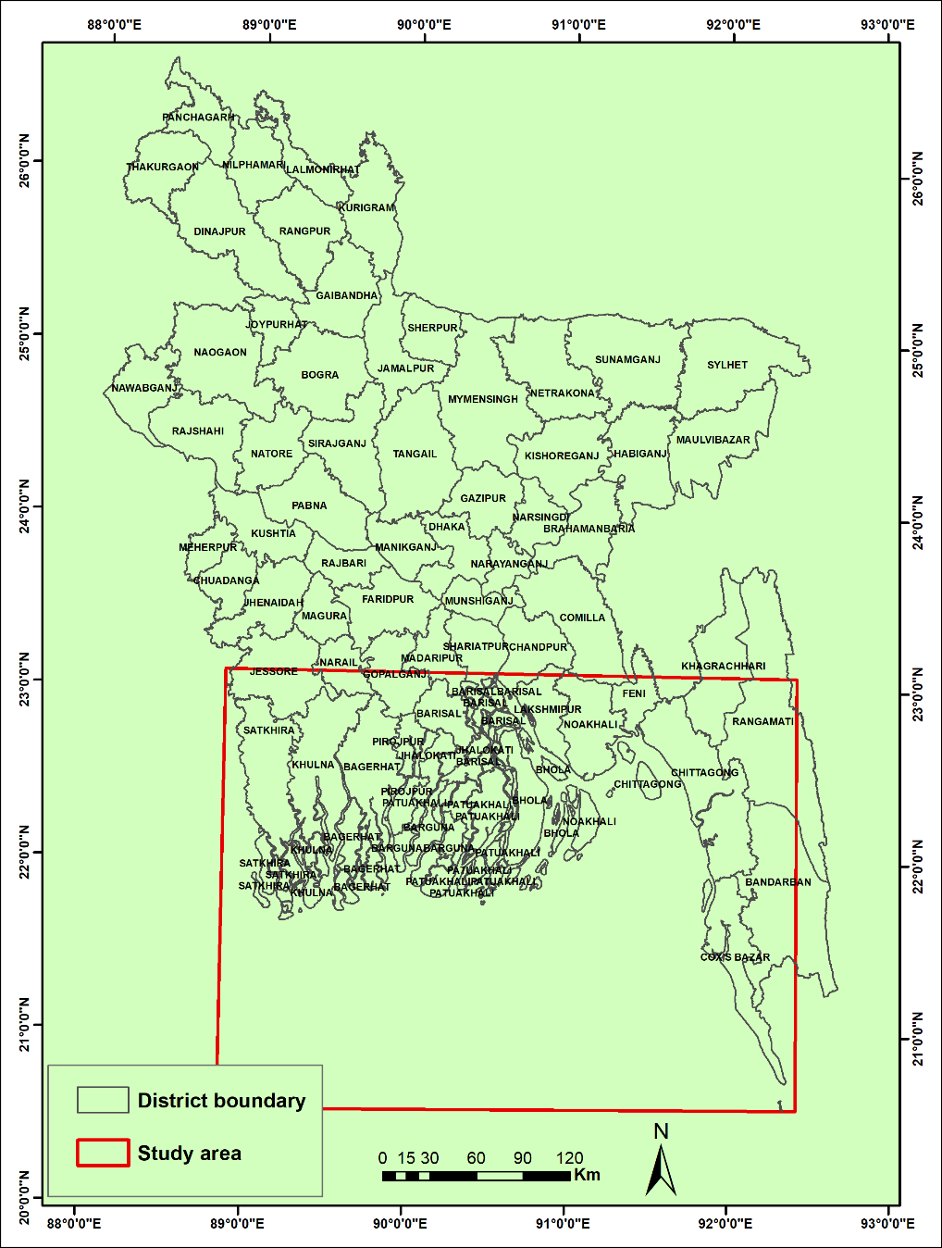

Figure 3.1 Coastal Area shows on District Boundaries

Table 3.1 Statistical information on the morphological changes of rivers in the coastal area

|  |  |  |  |  |
| --- | --- | --- | --- | --- |
| Year | Total area of river (in ha) | Duration | Erosion (Ha) | Accretion (ha) |
| 1989 | 708106 |  |  |  |
| 1995 | 690675 | 1989-1995 | 25938 | 43369 |
| 2000 | 710490 | 1995-2000 | 44133 | 23428 |
| 2005 | 695634 | 2000-2005 | 29576 | 42893 |
| 2010 | 687711 | 2005-2010 | 28579 | 38906 |
| 2015 | 700003 | 2010-2015 | 44494 | 33544 |
| 2020 | 690123 | 2015-2020 | 35470 | 40291 |

Figure 3.2 Morphological changes in rivers bank lines of coastal area

In the above Figure 3.2 presents that the bank lines are gradually eroded over the recent years from 1989 to 2020 where as the accretion of the rivers areas in some places are gradually increases over the recent years.

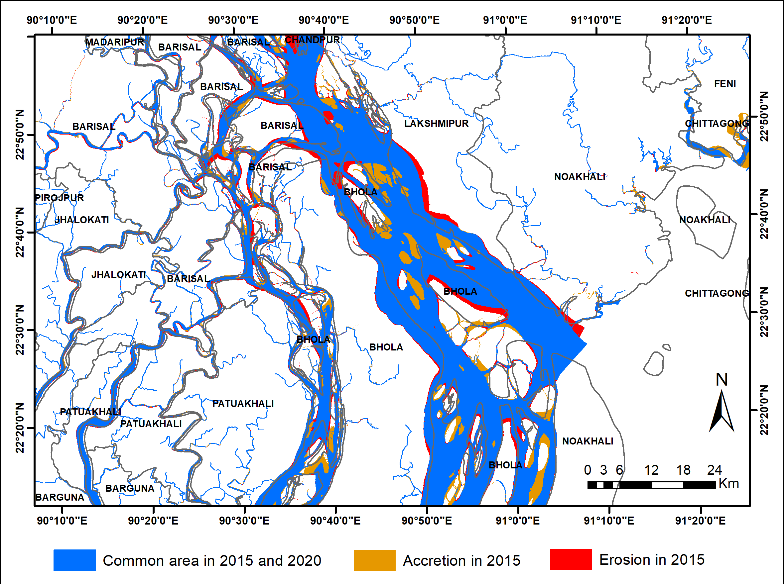

Figure 3.3 Sample map of the morphological changes during 2015-2020 in a part of the coastal area.

**Land Use change in the coastal area**

Landsat satellite images of the years 1990, 2000 and 2020 is being used for this work. Standard digital image processing techniques along with on-screen digitization are being used; these are georeferencing, classification, recoding, statistical filtering, raster to vector conversion, vector level refinement, class reconstruction using on-screen digitized data. About 55 % of the works has been completed so far.

## Web GIS Application Development

The Web GIS based database application entitled “Interactive Geodatabase for Coastal Zone (IGDCZ)” is currently under development stage. The overall progress of the development work of this application is about 60% where 10% development work has been done during 7th quarter of the project. The module-wise progress is presented in the following table:

| Sl No | Module | Purpose | Overall progress |
| --- | --- | --- | --- |
| 1 | Dashboard | A dashboard interface for accessing different modules in the Web GIS based application | 100% |
| 2 | GIS Core Module | Web GIS core mapping modules | 70% |
| 3 | Metadata Module | Metadata of Spatial and non-Spatial database of Application | 0% |
| 4 | Documents Archiving | Document Archive Library | 100% |
| 5 | Feedback | Feedback from users | 100% |
| 6 | Project Management | Module showing the progress of the development wok | 100% |
| 7 | Tutorial (help tutorial) | User manual/instruction for using the application | 100% |
| 8 | User Administration | User Administration Module for providing users to access the application | 100% |

### Work Plan

The development work has been conducted according a prepared workplan. Following Figure 3-4 shows the work plan with current status of different tasks and activities.

**Work Plan for IGDCZ Development**

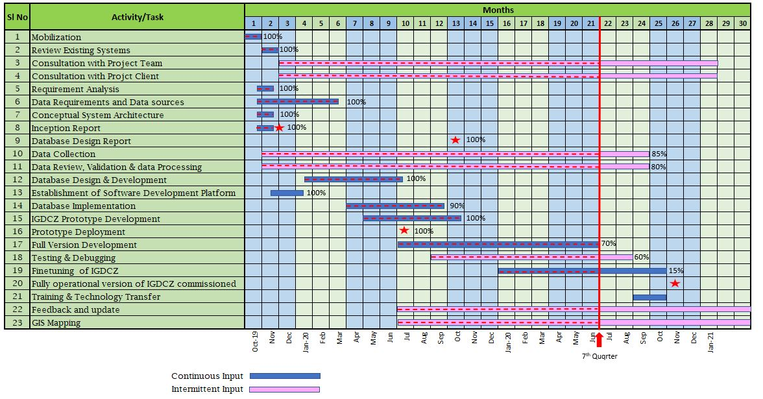

Figure 3.4 Work Plan

## Plan for Next Quarter

| **Sl No** | **Task & Activities** | **Progress (%) Upto 7th Quarter** | **Progress (%)**  **Plan for 8th Quarter** | **Overall Progress (%)** |
| --- | --- | --- | --- | --- |
| 1 | **Inception Phase** |  |  |  |
| 1.1 | Review Existing Systems | 100 | - | 100 |
| 1.2 | Consultation with Project Team | continue | - | continue |
| 1.3 | Consultation with Project Client | continue | - | continue |
| 1.4 | Requirement Analysis | 100 | - | 100 |
| 1.5 | Data Requirements and Data sources | 100 | - | 100 |
| 1.6 | Conceptual System Architecture | 100 | - | 100 |
| 1.7 | Inception Report | 100 | - | 100 |
| **2** | **Data Collection and Processing** |  |  |  |
| 2.1 | Coastal Bank Erosion (Satellite Image) | 100 | - | 100 |
| 2.2 | Land use Classification (Satellite Image) | 55 | 45 | 100 |
| 2.3 | Other Data Collection (shapefile & tabular) | 80 | 20 | 100 |
| 2.4 | Other Data Processing (shapefile & tabular) | 75 | 25 | 100 |
| **3** | **GIS Mapping** |  |  |  |
| 3.1 | Polder Maps for Data Collection | 50 | 50 | 100 |
| **4** | **Database Design & Development** |  |  |  |
| 4.1 | Database Design Development | 100 | - | 100 |
| 4.2 | Database Design Report | 100 | - | 100 |
| 4.3 | Database Implement | 80 | 20 | 100 |
| **5** | **Web GIS Application Development** |  |  |  |
| 5.1 | IGDCZ Prototype Development | 100 |  | 100 |
| 5.2 | Full Version Development | 70 | 20 | 90 |
| 5.3 | Testing & Debugging | 60 | 20 | 80 |
| 5.4 | Fully operational commissioning | - | - | - |
| **6** | **Training & Technology Transfer** | - | 50 | 150 |
| **7** | **Feedback and update** | continue | continue | continue |

## Sample Screenshots from Application

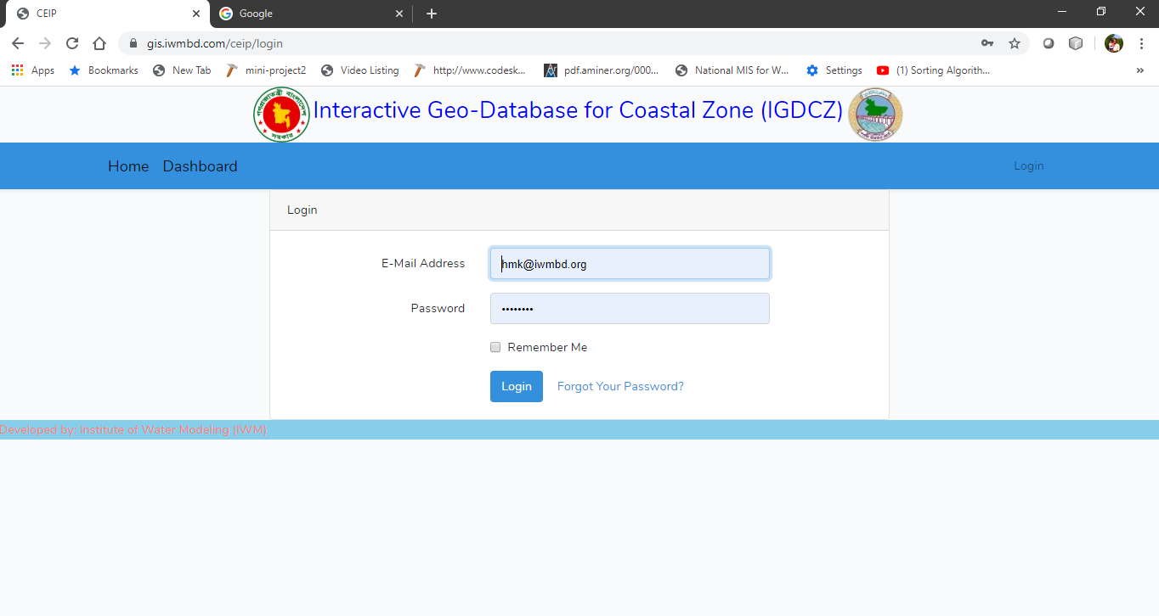

Figure 3.5 Application Login Page

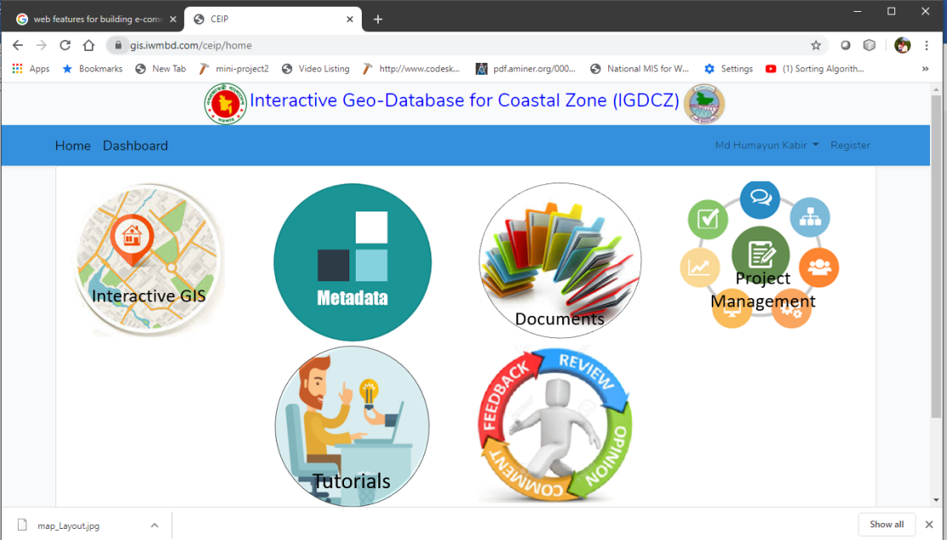

Figure 3.6 Application Dashboard

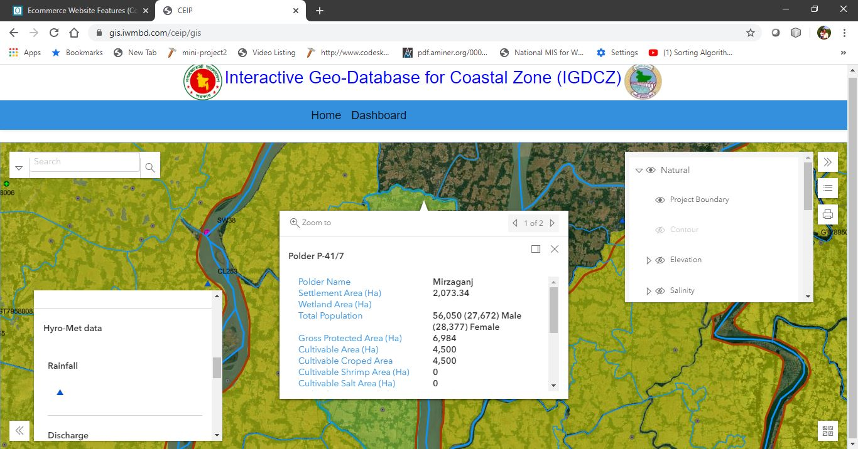

Figure 3.7 Web GIS Core Module

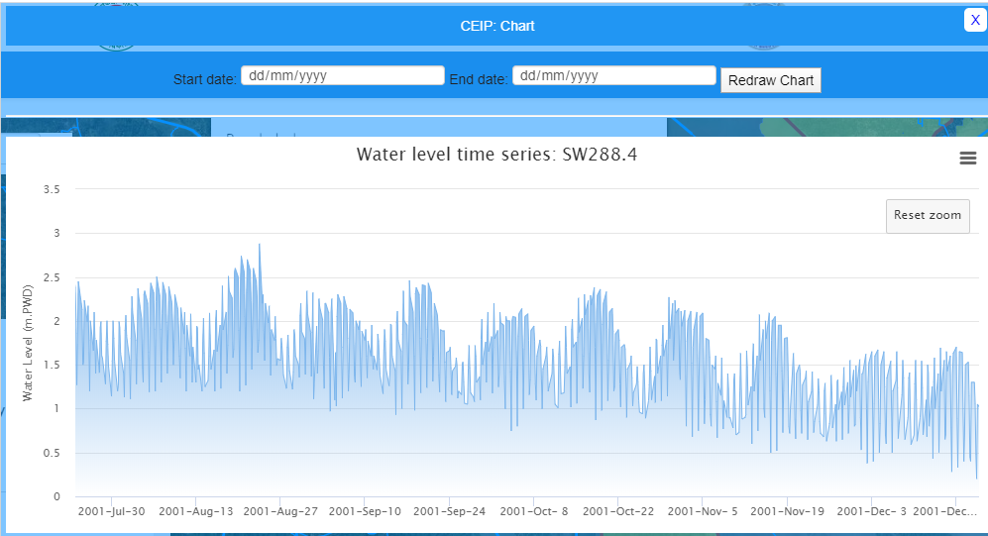

Figure 3.8 Sample Hydrograph of Surface Water Level Time Series Data

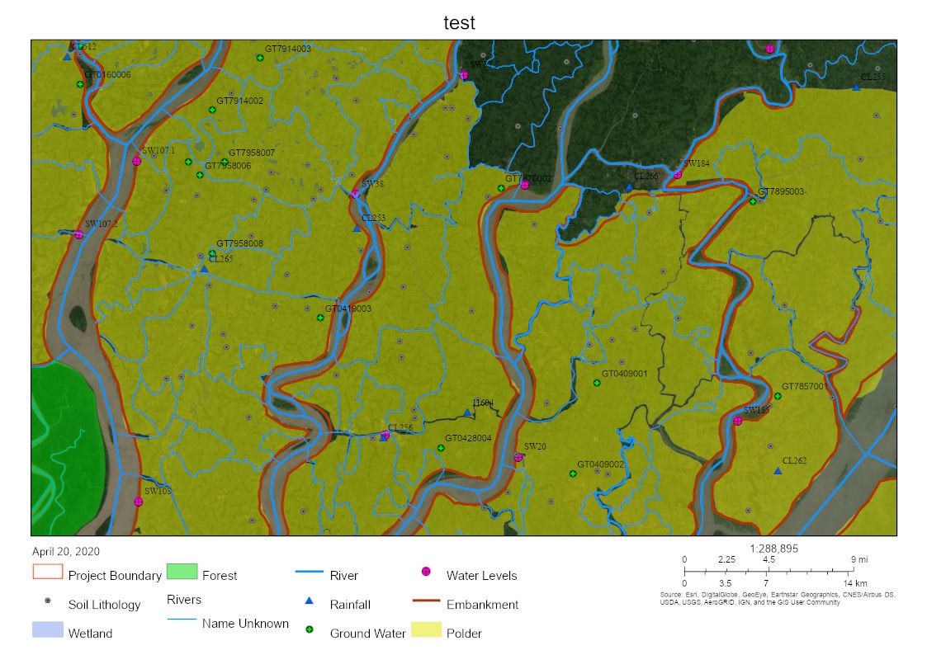

Figure 3.9 Sample Map output from Application

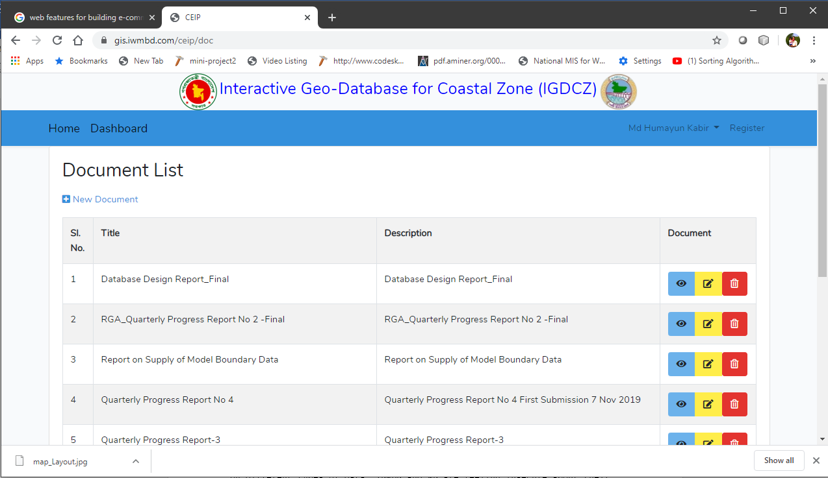

Figure 3.10 Document Archive Page

## User Access and Training

The Interactive Geodatabase for Coastal Zone (IGDCZ) is designed primarily for use by the BWDB and other agencies of the Ministry of Water Resources. There will be several levels of access including very restricted access for uploading and editing data, and broader access for downloading data for official use.

All authorised users will be provided with training – specially tailored to their respective levels of access.

These topics have been under discussion with the Client and the Bank and the logistics will be finalised in the next quarter

# MODELLING LONG TERM PROCESSESS

## Introduction

A very large proportion of the work carried out by the consultant on this project comprises the development and application of many types of mathematical models for predicting the long-term processes (evolution) of the conditions in the Bengal Delta. The evolution of the Bengal Delta under the disturbances imposed upon it by natural processes and by human interventions occur at many different length and time scales. Model development is now almost complete, and applications are underway.

There are many different types of models, using a variety of formulations and many versions of standard software being used in this study. Table 4.1 Lists the Models that are under development by the project team.

Table 4.1 Models currently under development



## Macro Scale Models: GBM Basin wide Applications

Table 4.2 Macro Scale Modelling



The main achievement during Q2 of 2020 has been the submission of the report “Interim Macro Scale Morphology - Current Situation”.

Context

The objective of the project is to create a framework for polder design, based on the long-term and large-scale dynamics of the GBM delta and on sustainable polder concepts. The macro-scale morphology described in this report is the first component in a cascade of spatial and temporal scales that are studied. The purpose of this first part is to:

1. Understand the large-scale sediment- and morphodynamics of the GBM delta

2. Predict and translate changes in external forcing conditions (due to climate change and anthropogenic activity)

The models developed in this component provide the tools to study sediment transport patterns in the delta (including sources and sinks) and assess the effect of changing boundary conditions on the sediment budget and the morphological development. As such, the macro-scale morphology component provides the essential low-resolution models required to translate these effects to high-resolution meso-scale models, on the scale of an individual river or estuary. This multi-scale model approach allows for a quantitative understanding on the effect of changes in external drivers on polder sustainability and its associated design criteria.

### The Hydrotrend model

HydroTrend is an empirical climate-driven, hydrological water balance and transport model that simulates water discharge and sediment load at a river outlet. Hydrotrend uses topographical drainage basin characteristics, like contributing basin area, glacial coverage and relief, as well as climatological parameters, like temperature and rainfall to estimate daily river dynamics (Kettner et al., 2008).

We have used the catchment hydrological model for the current situation to:

* estimate incoming total annual water and sediment fluxes for each of the upstream basins of the Ganges and Brahmaputra Rivers, which then can be propagated into the macroscale morphodynamics delta model (Delft-3D).
* estimate daily dynamics and analyse variability of suspended sediment fluxes for each of the Ganges and Brahmaputra Rivers.
* estimate future water and sediment fluxes under projections of a changing climate and upstream dam engineering for each of the Ganges and Brahmaputra Rivers.

The model can be set up for unique contributing river basins and requires a suite of input parameters to be specified for each basin. This project models the Ganges and Brahmaputra rivers as separate basins, since their basin properties and climatic conditions are distinctly different.

In this phase of the project HydroTrend will be used to forecast future sediment loads of the Ganges-Brahmaputra on a daily timescale with use of downscaled regional Earth System Models. These results will be used to force the GBM scale (process-based) models in a next phase (following report). In this phase a database of engineering measures proposed by the Indian Interlinkages River.



Figure 4.1 Map showing the Ganges and Brahmaputra basins

Scenarios we plan to use in the model

* Future with climate change;
* Future with implementation of Indian River Linking Project (IRLP);
* Future with both climate change and implementation of IRLP

Model outputs

The outfall of the model domain is at Farakka (not Hardinge bridge) in the Ganges and Bahadurabad in the Brahmaputra River. The model will provide the following outputs for base and future scenarios:

* Water discharge, discharge velocity, width and depth at the river mouth;
* Bed load and the suspended sediment concentrations for each grain size.

### Macro Scale Models: 2D Model of Large Rivers and Coastal System

Based on the calibration results for hydrodynamics and morphology change over periods in the order of 10-20 years the following progress were made during Q2 of 2020:

* The macro scale morphodynamic model runs robustly on a 25-year timescale, with acceptable run times (in the order of days on a cluster)
* Some important parameters have been identified and a clear parameter setting has been arrived at.
* This setting leads to a physically reasonable distribution of bed sediment, concentration patterns, net sedimentation areas including delta top set, and erosion hotspots.
* The model shows a predictable behaviour as a function of processes and boundary conditions;
* A detailed validation over a ~9 year period shows good agreement for gross and net volume changes and general patterns; there is an overestimation of overall sedimentation, erosion and net volume changes by factor 1.6, which is well within an acceptable range for morphodynamic models.
* Inclusion of wind and waves significantly improves the performance of the model in terms of reproduction of sedimentation, erosion and net volume changes.
* Straightforward boundary conditions can be applied that are easy to adjust to future scenarios.

In short, the macro-scale model has been developed to an acceptable level and can serve as a basis for future scenario runs.

Hydrodynamic and morphodynamic calibration and validation results have been described in the “Macro scale morphology – current situation” report.

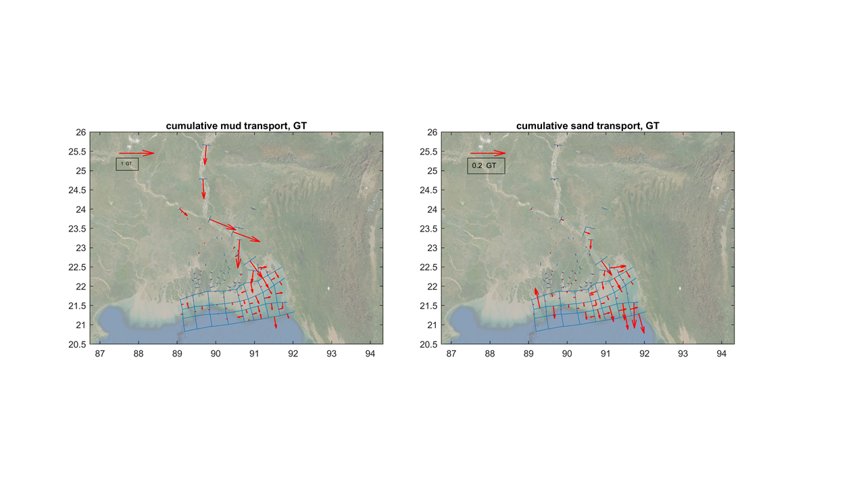

Figure 4.2 Yearly cumulative mud transports (left pane) and sand transports (right pane) in macro scale model, mind the different vector scales

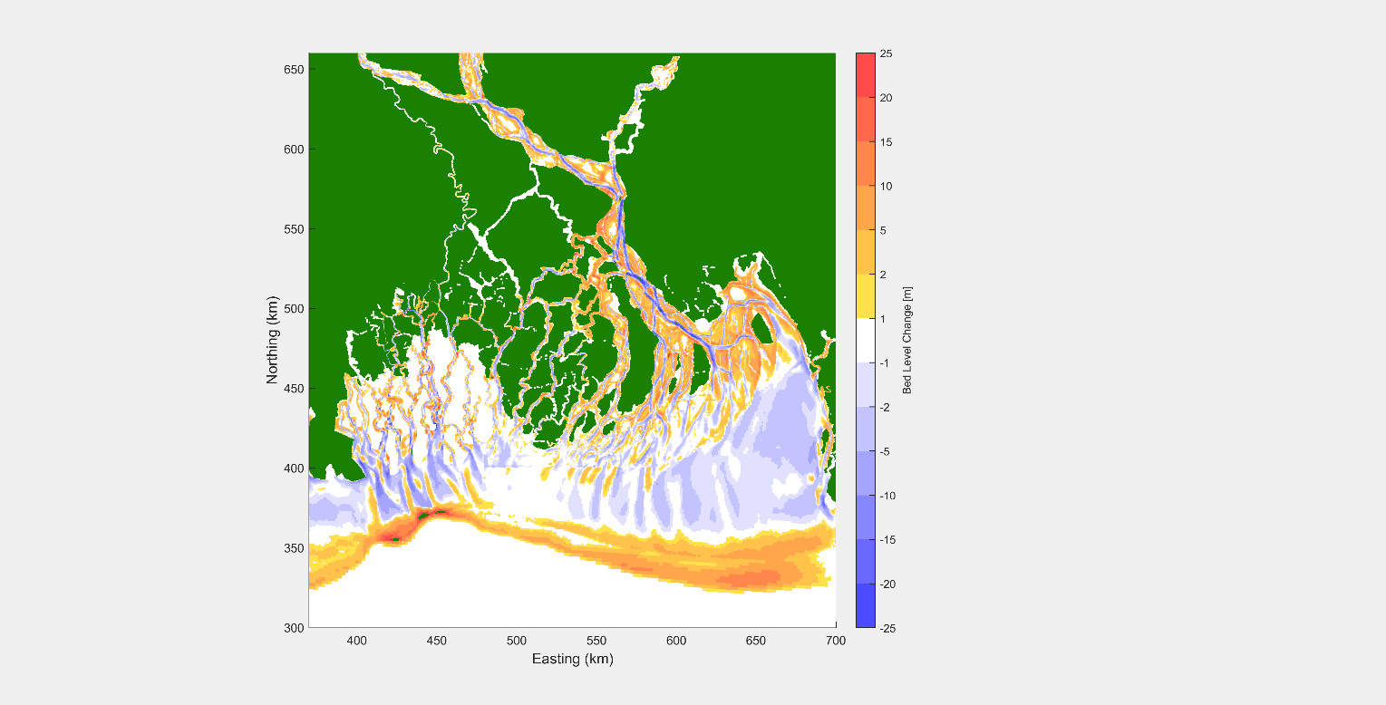

Figure 4.3 Simulated bed level changes, 2000-2019

### Macro Scale Models: 1D Model of Large Rivers System

The set-up of the model covers the Bangladeshi part of the GBM delta, from upstream of the three major rivers to the very downstream part of the large number of major estuaries bifurcating in the delta. The bathymetric representation of the model is set-up in two-fold; consisting of an approach with traditional cross-sectional profiles derived directly from observations, and an approach that involves constructing hybrid cross-sectional profiles to derive characteristic conditions suitable for long-term calculations.

The 1D model has been calibrated hydrodynamically against observed water levels and discharges. Applying the same sediment characteristics as in the 2D macroscale model described in previous section, we used the 1D sediment model to derive a sediment budget for the 1D model domain. Model results compared well to the results of the HydroTrend model although the suspended sediment load on the Jamuna river is 20% larger, and in the Ganges 25% smaller than observations. Future work will focus on finetuning these sediment loads.

1D model setup, calibration and sediment model results have been described in more detail in report “Macro scale morphology – current situation”.

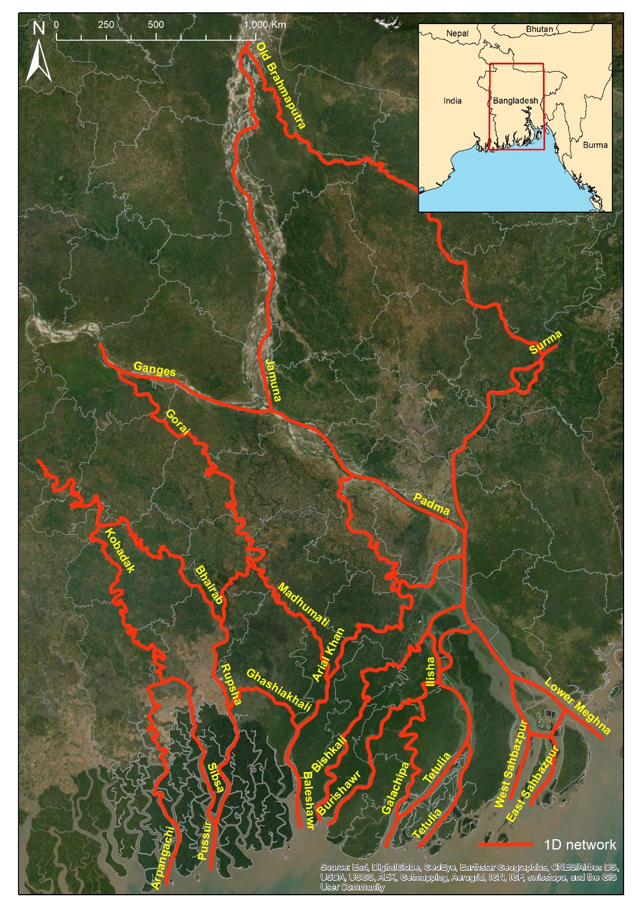

Figure 4.4 River network for the Delft3D-FM 1D model.

|  |  |
| --- | --- |
| C:\Users\SNN\AppData\Local\Microsoft\Windows\INetCache\Content.Word\1.jpg | C:\Users\SNN\AppData\Local\Microsoft\Windows\INetCache\Content.Word\2.jpg |

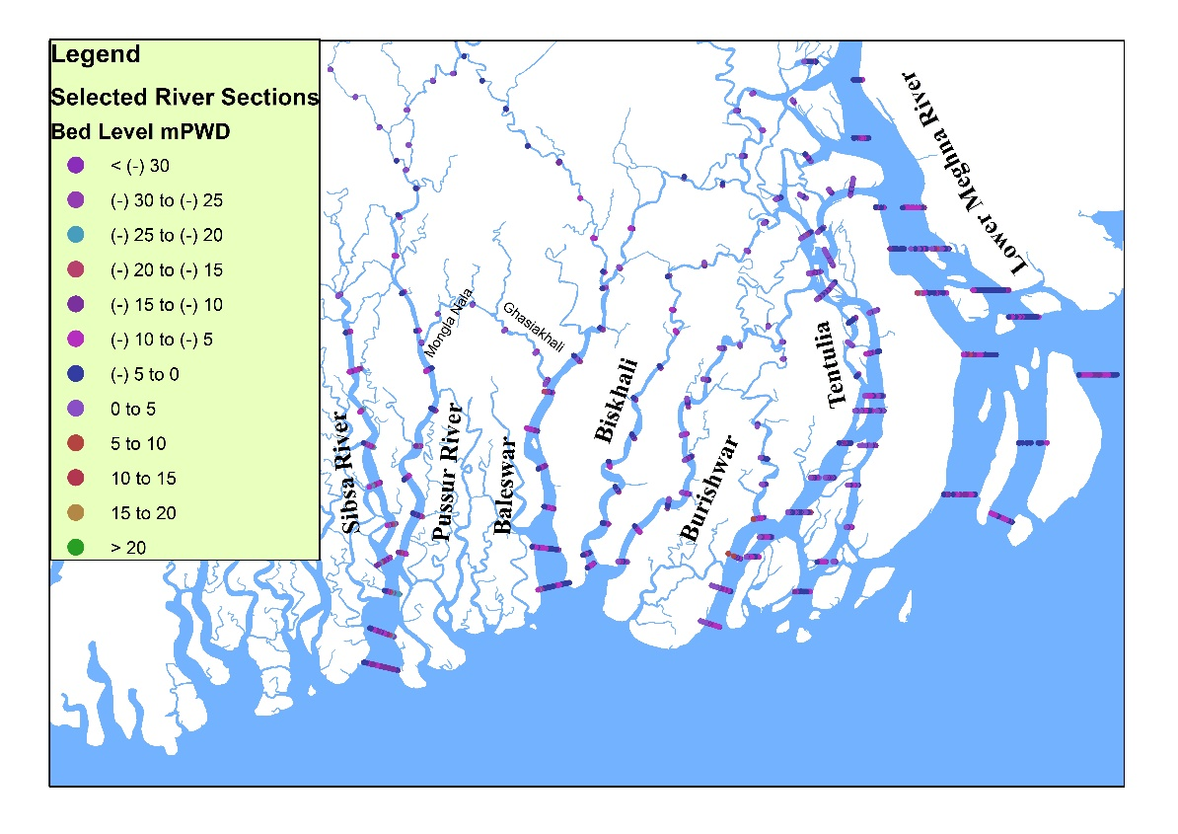

Figure 4.5 Maps showing the selected measured cross sections imposed on the model.

## Meso Scale Models for Long Term Morphology

Table 4.3 Meso Scale Modelling for Long Term Morphology



The main objective of this modelling is to develop morphological models for the selected rivers around the polder areas and estimate future long-term morphological changes under different scenarios. The selected meso scale modelling groups are following (Figure 4.7):

Pussur – Sibsa River system (Polder 32 & 33)

Baleswar – Bishkhali River system (Polder 35/1, 39/1, 39/2, 40/1, 40/2, 41 & 42)

Lower Meghna- Tentulia River system (Polder 56/57,55/1,55/2, 55/3 & 59/2)

Sangu River system[1] (Polder 63/1a, 63/1b & 64/1b)

The general approach for this modelling is the following:

* Preliminary study of historical morphological changes in the larger tidal rivers by using available bathymetry data
* Setup and Calibration – Setup, calibrate and validate the model with field measurements and remote sensing data.
* Morphological hindcast – reproduce the morphology from previous different periods.
* Scenario runs - Study future changes in the morphodynamic processes based on possible scenarios.
* Output - Geospatial datasets of erosion and sedimentation in the river system at present for various seasons and for possible scenarios 25, 50 and 100 years from now, for various seasons and circumstances

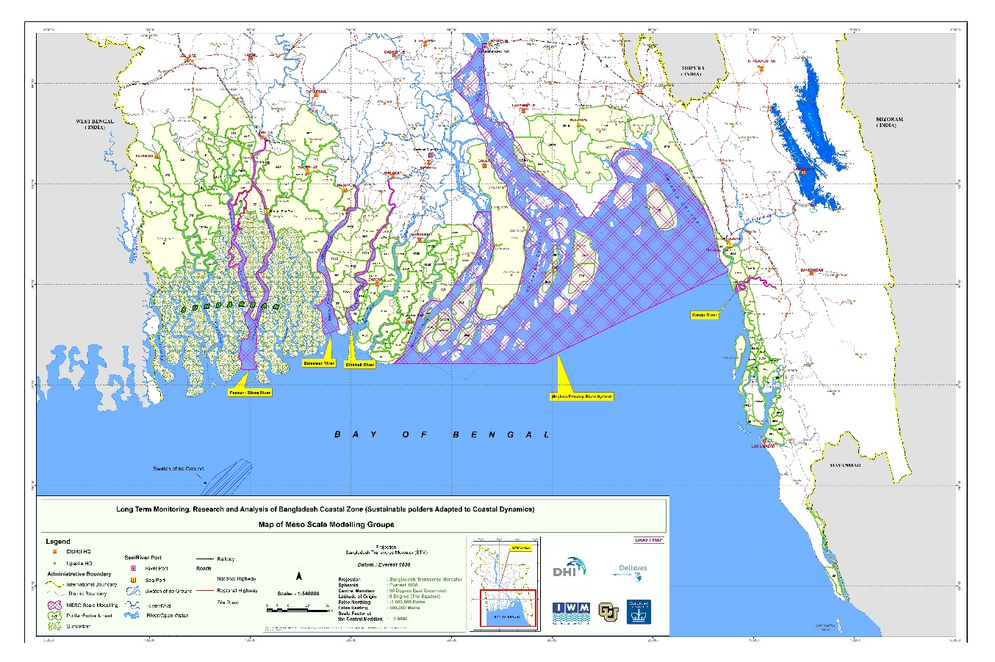

Figure 4.6 Map of meso scale modelling groups for long term morphology

### Pussur-Sibsa River system for meso scale modelling for long term morphology

Based on a hydrodynamic Pussur-Sibsa model calibrated and validated in previous months, we developed a Delft3D FM morphodynamic model based on an inventory of scarce bathymetries, bed sediment properties, water level observations and SSC measurements.

We validated the morphodynamics of the Pussur-Sibsa model against erosion and deposition patterns for the 2011-2019 period. This validation was based on adjusted sediment properties derived from the more advanced and successfully morphodynamically calibrated macroscale model. Preliminary model results show resemblances with observations, but deviations are yet too large for a successful hindcast.

The model results can be improved by further sensitivity analysis exploring the impact of dredging operations, wave action, and including estuary side channels and secondary channels connecting Pussur and Sibsa estuaries. Also, the model results appear to be quite sensitive to uncertain boundary conditions such as seaward and landward SSC concentrations and river flow discharges. An improved calibration will make this model suitable for exploring the impact of climate change scenarios.

Hydrodynamic and morphodynamic calibration and validation results have been described in the “Pussur-Sibsa morphological modelling study” report, which will be a separate volume of the deliverable “Interim Meso Scale Morphology - Current Situation”.

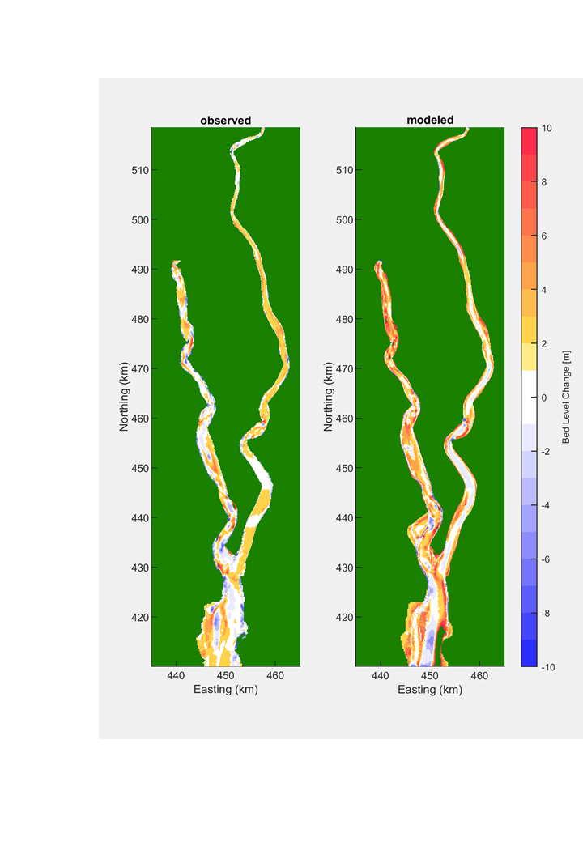

Figure 4.7 Sedimentation/erosion pattern after 9 years (2011 to 2019), measured (left panel) and modelled (right panel)

### Pussur-Sibsa River system for meso scale modelling for fine sediment

Report “Effect of human interventions on tidal and sediment dynamics in the Pussur-Sibsa basin” was delivered. This report will be a separate volume of the deliverable “Interim Meso Scale Morphology - Current Situation”. The report describes data analysis of tidal wave behaviour in the Pussur-Sibsa system under influence of human interventions over the past decades. The report includes extensive supportive modelling efforts on sediment dynamics in the systems exploring the impact of 3d flow, peripheral and connecting river systems

### Plume Model for Fine Sediment Pathways

Previous QRP’s describe the development of a Plume model to study the sediment pathways of sediment from the Meghna estuary into the ocean and presumably along the coastline into the Sundarbans. The Plume model has now been merged with the 2D Macro-scale model efforts described before. This was done since the 2D Macroscale model already describes the sediment plume in sufficient detail and because the 2D Macroscale model appeared to be computationally efficient to study plume dynamics. A major effort included schematised wind and wave action in the 2D Macroscale model that had considerable impact on sediment pathways along the Bangladeshi coast. Closer analysis is ongoing

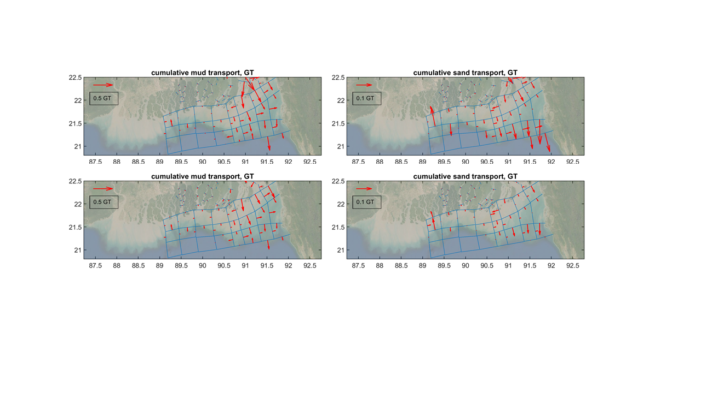

Figure 4.8 Yearly cumulative mud transports, details of (mind the different vector scales). Left panels are for mud. Top panels are with waves and wind. Lower panels are without waves and wind

### Baleswar-Bishkhali River system for meso scale modelling for long term morphology

Based on the hydrodynamic model of the Baleswar-Bishkhali estuary system, we developed a morphodynamic model to hindcast observed erosion and sedimentation patterns. The sensitivity analysis revealed that the model results were quite sensitive to sediment properties and (uncertain) boundary condition definitions including, for example, the schematized hydrographs and seaward boundary SSC levels. Ongoing sensitivity analysis further explores the best definition of these boundary conditions. This analysis will lead to settings that can make trustworthy and stable predictions with anticipated scenario runs.

### Lower Meghna Estuary for meso scale modelling for long term morphology

The model has been sufficiently calibrated and validated hydrodynamically in previous months and has been shown to represent time series of water levels and cross-sectional discharges accurately.

The morphological development has been tested for the period 2000-2009 and has shown an acceptable reproduction of sedimentation – erosion patterns and gross and net volume changes, with sediment settings similar to those of the macro-scale 2D model.

The shifting of bank lines due to encroaching channels could not be simulated yet, due to a problem related to the ‘dry cell erosion’ mechanism. It is recommended to solve this soon and also to develop and test a new algorithm based on a coupling with the ShorelineS model (Roelvink et al, 2020).

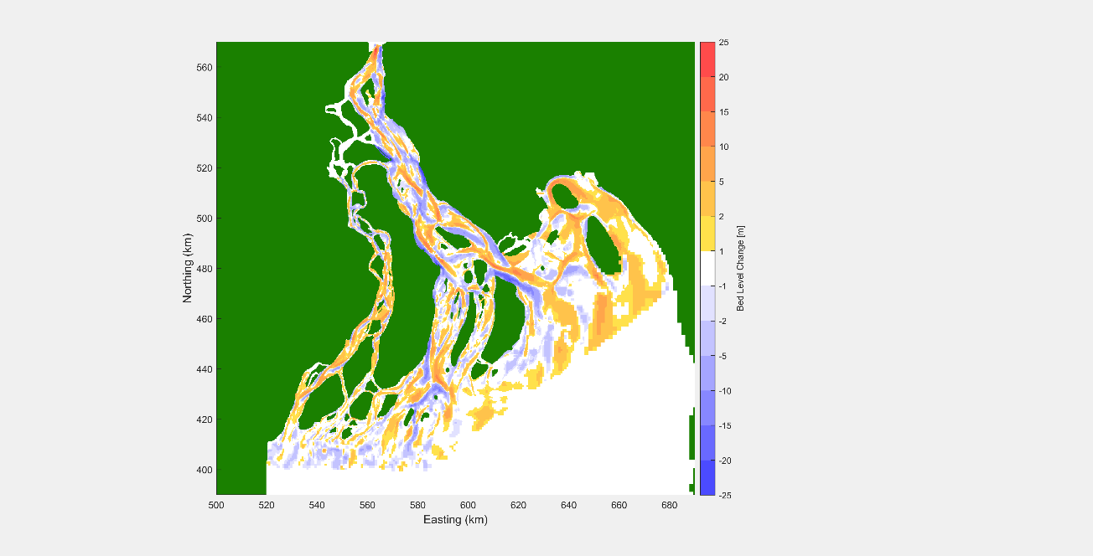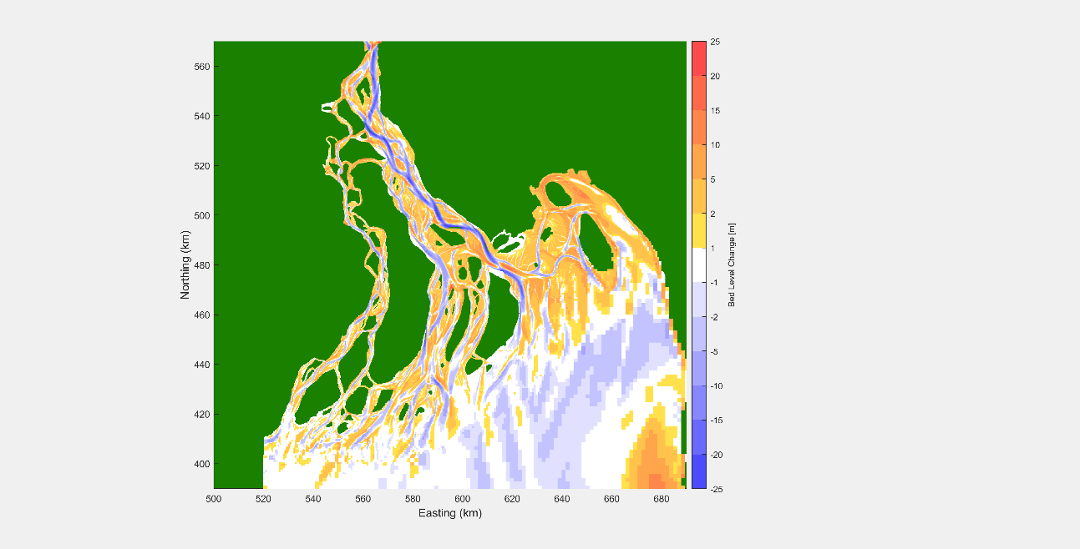

Figure 4.9 Observed (left panel) and simulated (right panel) bed level changes, 2000-2009, settings 2

### Sangu River system for meso scale modelling for long term morphology

Hydrodynamic calibration and validation have been ongoing for the Sangu River model. Calibrated and validated morphodynamic settings applied in the other three meso scale models will be used later to the Sangu River model.

## Meso Scale Models for Bank Erosion

Table 4.4 Meso Scale Modelling for Bank Erosion Prediction



Four models (Baleswar, Sibsa, Pussur, Bishkhali) have been completed during Q2 of 2020. The locations of the models are shown in Figure 4.10. Draft reports have been produced for each of the models and will be finalised when home time allocation will be available or after the travel ban is lifted.

### Introduction

IK-6 was ordered to return to Denmark on 15 March 2020 due to the corona situation. From 16 March and onwards work was focused on four MIKE 21C bank erosion models, listed from west to east, see also Figure 4.10:

* Sibsa
* Pussur
* Baleswar
* Bishkhali

These models have been brought to their final application form, and the associated model development reports are close to finalized.

Home time was available for the work, but only to cover a significant input until the end of June. No progress has been made in July due to lack of budget to cover home time.

No progress was made on the following two planned models:

* Lower Meghna
* Sangu

The reason for the lack of progress on these two models were unavailability of home time allocation, the necessary data and files were not available and could not be retrieved from Dhaka due to the corona lock down in Bangladesh.

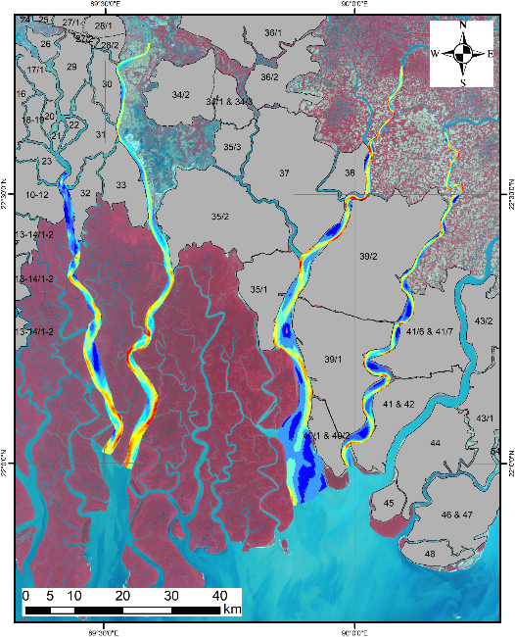

Figure 4.10 The four finalized MIKE 21C models, from west: Sibsa, Pussur, Baleswar, Bishkhali.

### Modelling template

The following principles have been driving the development of the models:

* Hydrometrics, sediment concentrations, bed levels, planform
* Calibrate to water levels and discharges
* Calibrate to observed bathymetry developments
* Reduced emphasis on calibrating to observed concentrations (unknown clay content)
* Calibrate to observed bank erosion
* Hindcast 2011-2019 to reduce uncertainties, except for Bishkhali River for which we only have 2019 bathymetry data

Curvilinear grids with similar properties have been finalized for each model, see Figure 4.11 for the Bishkhali grid. Similarly, we have prepared bathymetries, see Figure 4.12 for the Bishkhali 2019 bathymetry.

 

Figure 4.11 Curvilinear grid for the Bishkhali model, 800x15 grid points

 

Figure 4.12 Bishkhali River model bathymetry based on the 2019 bathymetry data contoured to the 2019 grid.

### Flow resistance and 3D flows in the riverbends

Investigations were conducted using local models in some of the sharp riverbends with the emphasis on the following:

* Impact of 3D flow (secondary flow convection of longitudinal momentum)
* Impact of flow resistance distribution

The 3D effect is documented in publications, see e.g. Lien et al (1999).



Figure 4.13 Local model covering the sharpest bends (268x30 grid cells) in Bishkhali River. This model was used for investigating the impact of flow resistance and 3D effects on the velocity profiles.

The investigations showed a consistent picture:

* The 3D effect has no discernible effect due to the relatively high B/h width to depth ratios of the rivers, while the bends do have quite high h/R depth to curvature ratios
* The flow resistance has a tremendous effect on the flow velocity distribution

Figure 4.13 shows the local model used for the analyses in Bishkhali River.

### Bed forms

We have investigated the van Rijn (1984) bedform regime predictor for the point bars in Pussur River.



Figure 4.14 Application of the van Rijn regime predictor for the point bars in Pussur River.

The investigation showed that the point bars in Pussur River are very likely to be dune covered, see Figure 4.14. The very fine sand (0.125 mm) found in the rivers will form ripples for very low flow velocities and dunes for the flow velocities characterizing the conditions during ebb and flood. The van Rijn regime predictor also suggests that we do not get into the upper plane bed for the velocity range on the bars we simulate with the model. The presence of dunes has a significant influence on the flow resistance, easily adding form resistance in the same order as skin friction, and usually more. Bed forms were not accounted for in the flow resistance for Pussur where instead we used sand-silt interaction to explain the persistence of the point bars. For Bishkhali we implicitly included dunes via an alluvial resistance model. For Sibsa and Baleswar we do not model sand, and the model investigations did not favor using alluvial resistance models, but instead just simple Manning formulations.

### Sand-silt interaction

To simulate the point bars in Pussur River correctly, it was necessary to refine the model description of sand-silt interaction. Without the refinement, the point bars would disappear. The adopted sand-silt interaction model can be found in van Ledden (2003).

### Bank erosion

It was quickly realized that bank erosion in the coastal zone is slow and systematic compared to what we observed in the fluvial systems in Bangladesh. For instance, in the Jamuna River bank erosion rates can be as high as 1 km/year, which makes it hard to predict the development of the river more than a few monsoon seasons ahead - this in contrast to the rivers and estuaries in the coastal zone.

 

Figure 4.15 Illustration of the differences between the 2011 and 2019 grids, which cannot be identified without looking at the details. This is Baleswar, just upstream of the Gashiakali inflow where the eastern bank has been eroding consistently. The 2019 grid conforms to the 2019 bank line, as seen in the figure. The bank line moved roughly 100 m from 2011 to 2019.

Figure 4.15 shows bank line shifting in the Baleswar River along with the adaptive grid that is updated to account for the bank line shifting in the model.

As also outlined in the literature review there are two primary reasons why we are dealing with much more predictable behavior compared to what we normally see in Bangladesh:

* The banks are cohesive
* The rivers are tidal

The cohesive banks are far more erosion resistant than the sandy banks we see along e.g. Jamuna River. The main scientific reference for the bank erosion formula (Hasegawa, 1989) also mentions that cohesion significantly lowers bank erosion when using his formula.

The tidal discharges in the rivers dominate the monsoon discharges, the latter being difficult to identify from hydrographs without calculating the daily mean flow. The dominating tidal discharge means that the rivers are not experiencing significant seasonal variations in the forcing that drives the morphological development. In other words, the tidal rivers are not as out of equilibrium during the monsoon, as we see for the fluvial systems. Therefore, the need for adjusting towards a new dynamic equilibrium during the monsoon is much reduced in the tidal rivers. Due to the reasonably adjusted rivers we also see mellow flow conditions in the tidal rivers compares to what we observed in the fluvial systems during the monsoon. Monsoon velocities in fluvial systems in Bangladesh are often around 3 m/s, which we have not observed in any of the tidal rivers. In the tidal rivers, high velocities are typically 1-1.5 m/s.



Figure 4.16 Bank line changes based on Landsat in the sharpest bend of Bishkhali River in the period 1988-2019. The bank lines show very systematic and relatively slow erosion (typically up to 10-20 m/year, and Bishkhali has the highest erosion rate of the four rivers studied thus far; not that Lower Meghna will change that). Bank accretion can also be observed, but this is not modelled, except as a passive process in which deposition will take place in the riverbed. The observed bank lines for Bishkhali exhibit textbook behavior.

Various bank erosion formulations have been tested in the models, viz.:

* Toe erosion, see Mosselman (1995)
* Traditional excess shear stress, Mosselman (1995) is good for an overview
* Critical bank height formulation, see e.g. Mosselman (1995)
* Excess velocity formulation, see Hasegawa (1989)

The excess velocity formulation turned out to be the most suitable to use. However, we are not using the formula in its original form, which involves the near-bank excess velocity relative to e.g. the mean velocity in the local cross-section. The reasoning behind this was that the local average velocity is only meaningful for rivers with one-point bar and a bend scour, but we often see islands in the cross-sections, and the flow is tidal. Therefore, we modified the formula by estimating the average velocity from the near-bank velocity:

$$E_{b}=E_{Hasegawa} V\left(1- {\left(\frac{h_{c}}{h}\right)}^{2/3}\right)$$

Where V is the near-bank velocity, h the near-bank water depth and hc a typical average depth. EHasegawa needs to be calibrated. The work showed that this formula derived from Hasegawa works well in all four rivers models, and with almost identical parameters.

Figure 4.17 shows the observed bank erosion along Bishkhali as function of the longitudinal distance along the river (chainage), while Figure 4.18 shows the simulated erosion compared to observations. The agreement is very convincing in all the rivers. There are significant local quantitative shortcomings, but qualitatively the models get the majority of the eroding banks correctly located.



Figure 4.17 Observed bank erosion as function of chainage in Bishkhali River 2011-2019 for the east and west banks. The 2019 bed levels along the banks are shown as well to illustrate the strong correlation between bed levels and bank erosion, which we also see for Sibsa, Pussur and Baleswar. Note: We do not have a 2011 bathymetry for Bishkhali.





Figure 4.18 Observed and simulated bank erosion 2011-2019 comparison along the east and west bank of Bishkhali River.

### Overview of the four finalized models

Four models have bene finalized during Q2 of 2020. These models have many similarities, but also differences. Many parameters are almost identical in the models. Table 4.5 compares the various parameters used in the models.

Table 4.5 Parameters for the four finalized models

|  |  |  |  |  |
| --- | --- | --- | --- | --- |
| Model | Sibsa | Pussur | Baleswar | Bishkhali |
| Grid size | 500 x 20 | 500 x 10 | 792 x 20 | 800 x 15 |
| 2011 bathymetry | Yes | Yes | Yes | No |
| 2019 bathymetry | Yes | Yes | Yes | Yes |
| Silt | Yes | Yes | Yes | Yes |
| Silt fall velocity | 1 mm/s | 1 mm/s | 1 mm/s | 1 mm/s |
| Silt critical shear stress | 0.2 N/m2 | 0.2 N/m2 | 0.2 N/m2 | 0.2 N/m2 |
| Silt erosion coefficient | 0.015 g/m2/s | 0.02 g/m2/s | 0.02 g/m2/s | 0.02 g/m2/s |
| Silt deposition shear | 0.1 N/m2 | 0.1 N/m2 | 0.1 N/m2 | 0.1 N/m2 |
| Sand | No | Yes | No | Yes |
| Sand grain size |  | 0.125 mm |  | 0.125 mm |
| Sand fall velocity |  | 0.0143 m/s |  | 0.0143 m/s |
| Sand transport model |  | Same as silt |  | Garcia & Parker |
| Sand-silt interaction | No | Yes | No | No |
| Initial PSD |  | Estimated |  | Simulated |
| Flow resistance model | M=50 m1/3/s | M=60 m1/3/s | u/s M=35 m1/3/s  d/s M=50 m1/3/s | M=25h1/2 |
| Hasegawa depth | 10 m | 8 m | 10 m | 10 m |
| Hasegawa coefficient | 10-6 | 10-6 | 10-6 | 1.5x10-6 |
| Side channels | 9 | 6 | 5 | 0 |
| Upstream SSC | 200 g/m3 | f(Q) | 200 g/m3 | f(Q) |
| Downstream SSC | 200 g/m3 | 100/0 g/m3 | 400 g/m3 | 80/20 g/m3 |

Bank erosion: The parameters are almost identical, but we also know that e.g. Pussur is distinctly shallower than Sibsa and we can see that Bishkhali has distinctly higher erosion rates than the other three rivers. The increased erosion rates for Bishkhali make sense because the river is located furthest to the east, and therefore we expect less cohesion in the riverbank (we do not have riverbank sediment samples from Bishkhali).

Cohesive sediment: The four rivers have almost identical silt models, with only a small deviation in the Pussur silt entrainment coefficient. All models have the same deposition shear stress limit.

Sand transport: Sibsa and Baleswar do not contain sand in the model, while Pussur has sand modeled with sand-silt interaction and Bishkhali has sand modeled using Garcia & Parker (1991) suspended load.

### References

Mosselman, E. (1995). A review of mathematical models of river planform changes. Earth Surface Processes and Landforms, 20(7), 661-670.

Hasegawa, K. (1989). Universal bank erosion coefficient for meandering rivers. Journal of Hydraulic Engineering, 115(6), 744-765.

Garcia, M., & Parker, G. (1991). Entrainment of bed sediment into suspension. Journal of Hydraulic Engineering, 117(4), 414-435.

van Ledden, M. (2003). Sand-mud segregation in estuaries and tidal basins (p. 221). Sydney: University of Technology.

van Rijn, L. C. (1984). Sediment transport, part III: bed forms and alluvial roughness. Journal of hydraulic engineering, 110(12), 1733-1754.

Lien, H. C., Hsieh, T. Y., Yang, J. C., & Yeh, K. C. (1999). Bend-flow simulation using 2D depth-averaged model. Journal of Hydraulic Engineering, 125(10), 1097-1108.

## Morphological Models for TRM (Micro Scale)

Table 4.6 Morphological Modelling on Micro-scale



Tidal River Management has been implemented in some of the polders (polder 6-8 and Polder 24) in south western region. After detailed study of reports on tidal river management (TRM) Polder 24 has been identified as a good case for a pilot model. IWM collected data at Polder 24 before and after the implementation of the TRM. The available data include:

* River cross-sections, several datasets were collected
* Floodplain elevations, including levees (very important for the hydraulics)
* Discharges and water levels (tidal cycle)
* Sediment particle size distribution data
* Sediment concentrations during the tidal cycle

A 1D Pilot Tidal River Management model was developed for Polder 24 (see e.g. QPR-6). The network of that model is shown in Figure 4.19. The 1D Pilot Model have been followed by a full 2D TRM model of Polder 24.

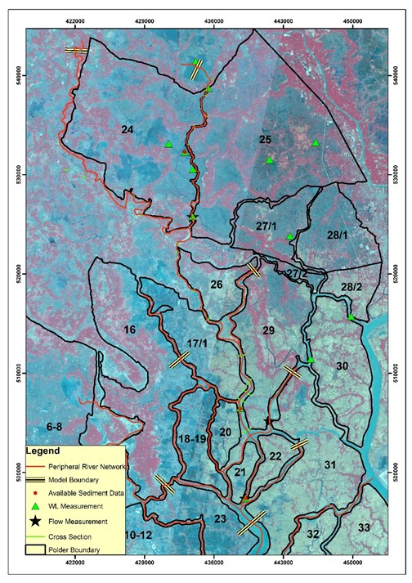

Figure 4.19 River Network for Mike 11 Model Extracted from SWRM

### Pilot Tidal River Management (TRM) model for Polder 24

The time scales and optimal lifetime for TRM operation have been examined using the TRM basin in Polder 24 (East Beel Khuksia) as conceptual test case. By using a cyclic morphological approach covering a period of 6 years annual impact is estimated and identified for both polder and river branch. shows the initial bathymetry of the polder and the Hari River branch and the morphological development of bed levels the following six years after the opening into the southern part of the polder.

|  |  |  |  |
| --- | --- | --- | --- |
|  |  |  |  |
|  |  |  |  |

Figure 4.20 Bed level development after activation of TRM at the southern end of the polder in the consecutive period of 6 years.

The corresponding plot showing the accumulated bed level changes is shown in . From the plots it is seen how the siltation pattern gradually migrate into the polder during the first 3 years. The presence of an old channel network makes it possible for the sediment being flushed to penetrate far inside the polder and distributed into the floodplains where calm flow conditions allow sediment to settle. The plots also show a significant erosion taking place inside the Hari River branch downstream the opening into the polder. Erosion is also taking place in parts of the channel network inside the polder. This erosion is important to maintain the flushing ability of the polder and capability to penetrate water and sediment into the entire polder.

|  |  |  |  |
| --- | --- | --- | --- |
|  |  |  |  |
|  |  |  |  |

Figure 4.21 Bed level changes after activation of TRM at the southern end of the polder in the consecutive period of 6 years.

shows the annual sedimentation and erosion inside the polder and the Hari River branch. It is seen that sediment is mainly settling in the southern part during year 1. In year 2 deposition is migrating to the middle part, while at the same time the channel network is eroding. In year 3 settling are mainly taking place in the northern part of the polder. In this year the Hari River branch reaches an equilibrium, i.e. erosion has stopped. In year 4-6 the tidal volume of the polder is decreasing leading to siltation in the Hari River branch and the channel network inside the polder. The TRM has therefore lost its eligibility after 4 years.

|  |  |  |  |
| --- | --- | --- | --- |
|  |  |  |  |
|  |  |  |  |

Figure 4.22 Annual bed level changes after activation of TRM at the southern end of the polder in the consecutive 6 years.

The achieved impact obtained by use of TRM is illustrated in . The diagram shows the area inside the polder which is located above a given bed level value for initial conditions and the consecutive 6 years. It is seen that it is primarily the first 3 years the TRM is well-functioning. Siltation is also taking place in year 4-6, but this is main in the drainage network, which is of severe importance for the operation of the polder after TRM operation has stopped.



Figure 4.23 Area inside polder above a certain bed level during TRM operation.

A similar diagram is made for the Hari River branch and shown in . It is seen that significant (but favourable) erosion takes place during the first year. The erosion continues in the two following years, but with less pace. In year 4 sediment starts to settle in the river branch and the siltation continues in year 5 and 6 as the tidal prism of the polder decreases.



Figure 4.24 Area inside Hari River branch above a certain bed level during TRM operation.

The continuing work will focus on siltation of the Hari River branch without TRM operation and modelling of other polder openings. The present investigated opening was made into an old main channel branch, it will be relevant to compare the TRM performance of this system with an opening in the mid part.

# OTHER STUDIES

## Subsidence and Delta Building

Field work on subsidence and delta building have continued during Q2 and is described in Chapter 2, Section 2.3.

## Climate Change Effects (analysis of historical data)

This section does not include any progress specific to this Quarter as the relevant experts have exhausted their home time allocation.

### Rainfall

Time series of 32 rainfall stations were available to the project, see and . shows the data availability for these stations; gaps in the lines represent missing data. It shows there is substantial variation in data availability for the various stations. Years with more than 5% missing data were excluded from the analysis.

shows the annual average rainfall as derived from this data set. For verification purposes, a comparison is made with an annual average rainfall map from Shahid et al (2011). It shows these results are in very good accordance. This seems logical as the same data is likely to be the basis of both figures, but nevertheless a useful verification/validation for both studies.

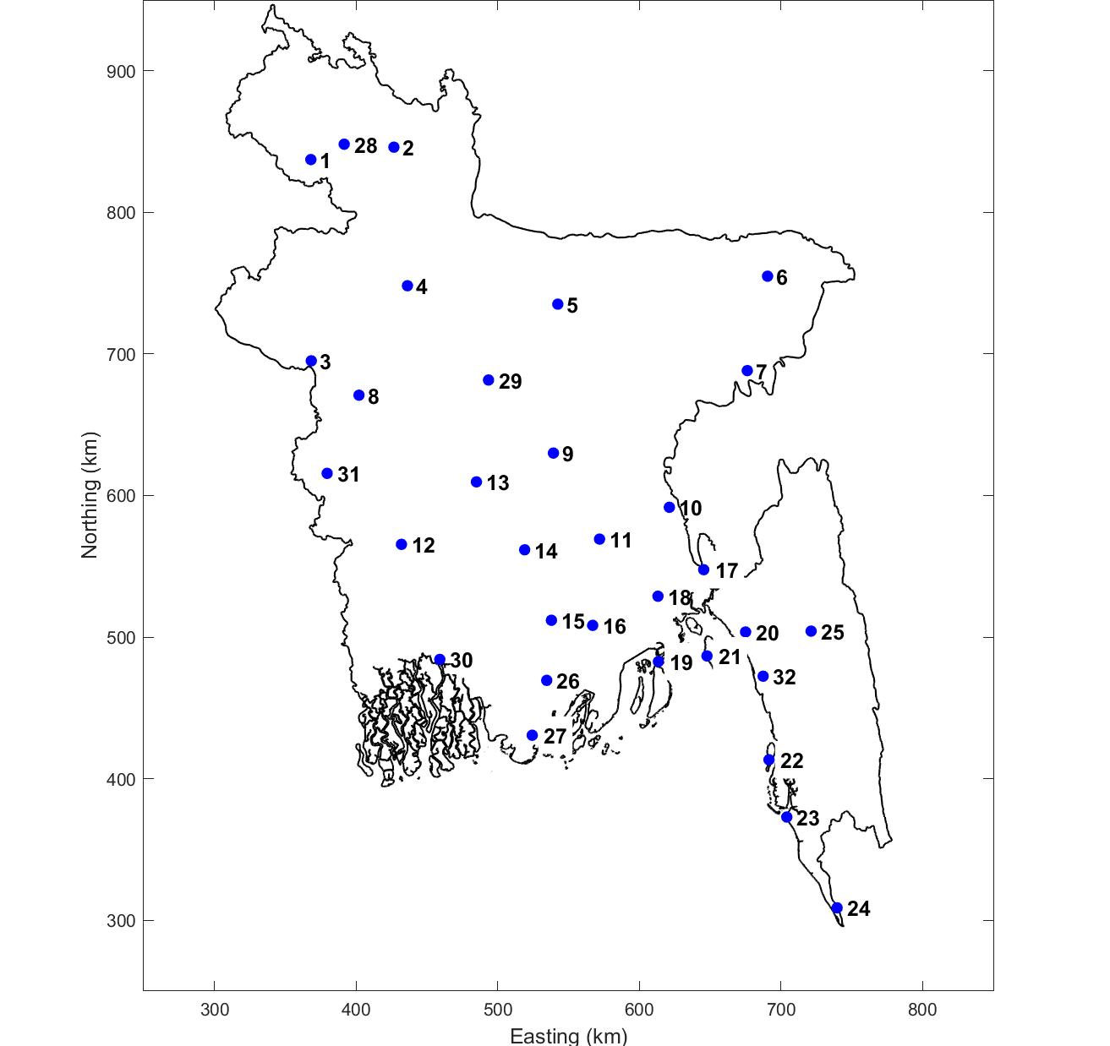

Figure 5.1 Rainfall stations (32 in total) for which data was available to this project.

Table 5.1 Names and coordinates of the 32 rainfall stations of .

|  |  |  |  |  |  |  |  |  |
| --- | --- | --- | --- | --- | --- | --- | --- | --- |
| **no** | **station** | **lat** | **lon** |  | **no** | **station** | **lat** | **lon** |
| 1 | Dinajpur | 25.65 | 88.68 |  | 17 | Feni | 23.03 | 91.42 |
| 2 | Rangpur | 25.73 | 89.27 |  | 18 | Maijdee Court | 22.87 | 91.10 |
| 3 | Rajshahi | 24.37 | 88.70 |  | 19 | Hatiya | 22.45 | 91.10 |
| 4 | Bogra | 24.85 | 89.37 |  | 20 | Sitakunda | 22.63 | 91.70 |
| 5 | Mymensingh | 24.73 | 90.42 |  | 21 | Sandwip | 22.48 | 91.43 |
| 6 | Sylhet | 24.90 | 91.88 |  | 22 | Kutubdia | 21.82 | 91.85 |
| 7 | Srimangal | 24.30 | 91.73 |  | 23 | Coxs Bazar | 21.45 | 91.97 |
| 8 | Ishwardi | 24.15 | 89.03 |  | 24 | Teknaf | 20.87 | 92.30 |
| 9 | Dhaka | 23.78 | 90.38 |  | 25 | Rangamati | 22.63 | 92.15 |
| 10 | Comilla | 23.43 | 91.18 |  | 26 | Patuakhali | 22.33 | 90.33 |
| 11 | Chandpur | 23.23 | 90.70 |  | 27 | Khepupara | 21.98 | 90.23 |
| 12 | Jessore | 23.20 | 89.33 |  | 28 | Syedpur | 25.75 | 88.92 |
| 13 | Faridpur | 23.60 | 89.85 |  | 29 | Tangail | 24.25 | 89.93 |
| 14 | Madaripur | 23.17 | 90.18 |  | 30 | Mongla | 22.47 | 89.60 |
| 15 | Barisal | 22.72 | 90.37 |  | 31 | Chuadanga | 23.65 | 88.82 |
| 16 | Bhola | 22.68 | 90.65 |  | 32 | Chittagong (City) | 22.35 | 91.82 |



Figure 5.2 Data availability for the 32 rainfall stations. Gaps in the line indicate missing data.

|  |  |
| --- | --- |
|  |  |

Figure 5.3 Annual average rainfall: comparison between results from Shahid et al [2011] (left) and this report (right).

shows derived trend classes based on the measured data presented for the annual total (sum) rainfall, analyzed using the Mann-Kendall test (right subplot). The results are compared to the results of Shahid (2009) (left plot). It shows no major trends over the entire Bangladesh as both, darkest red to darkest blue colors are observed. Overall, there are more locations with an increasing trend than locations with a decreasing trend, therefore suggesting an overall increase in total rainfall. In particular, in the northwest and along the coastline there are several locations with an increasing trend.

|  |  |
| --- | --- |
|  |  |

Figure 5.4 Trends in annual total rainfall: comparison between the results from Shahid (2009) (left) and this report (right).

The trend classes for the annual total rainfall as derived with other three statistical tests are very similar to the one shown for the Mann-Kendall test in ; as such confirming the seemingly apparent increasing trend in the Northwest and along the coastline.

shows the resulting trend classes when all 32 stations are combined. Several tests indicate that the winter season has an overall negative trend, whereas the post-monsoon season and the whole year have an increasing trend.

Table 5.2 Derived trend classes for rainfall for the combination of all stations. Results are shown for two indicators, four statistical tests and five different seasons (including the whole year).

|  |  |  |  |  |  |  |  |  |
| --- | --- | --- | --- | --- | --- | --- | --- | --- |
| Indicator: | Total rainfall (sum) | | | | Maximum daily rainfall | | | |
| test: | PS | MK | SM | WMW | PS | MK | SM | WMW |
| Year | 1 | 1 | 1 | 0 | 0 | 0 | 0 | 0 |
| Pre-monsoon | 0 | 0 | 0 | 0 | 0 | 0 | 0 | 0 |
| Monsoon | 0 | 0 | 0 | 0 | 1 | 0 | 0 | 0 |
| Post-monsoon | 1 | 0 | 1 | 0 | 0 | 1 | 0 | 0 |
| Winter | 0 | -1 | -1 | 0 | -1 | -1 | -2 | 0 |

### Temperature

Time series of 34 temperature stations were available to the project, see . shows the data availability for these stations; gaps in the lines represent missing data. It shows there is substantial variation in data availability for the various stations. Years with more than 5% missing data were excluded from the analysis. shows derived annual average temperatures (right) and compares them with corresponding results from MOEF (2005) (left). Both figures show a clear temperature gradient from east to west. The values from MOEF (2005) are higher, though, this is most likely the difference between mean daily rainfall (our data) and daily maximum temperature (MOEF, 2005).

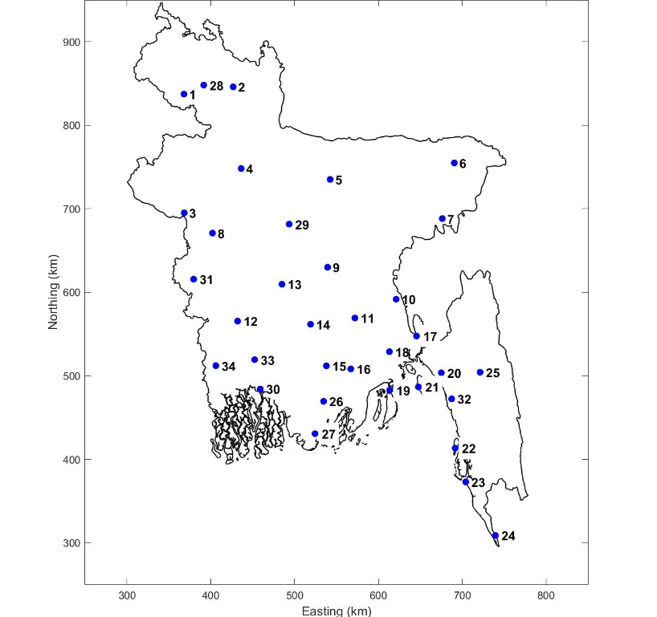

Figure 5.5 Temperature stations (34 in total) for which data was available to this project.

Table 5.3 Names and coordinates of the 34 rainfall stations of Figure 5.5.

|  |  |  |  |  |  |  |  |  |
| --- | --- | --- | --- | --- | --- | --- | --- | --- |
| no | station | lat | lon |  | no | station | lat | lon |
| 1 | Dinajpur | 25.65 | 88.68 |  | 18 | Bhola | 22.68 | 90.65 |
| 2 | Rangpur | 25.73 | 89.27 |  | 19 | Feni | 23.03 | 91.42 |
| 3 | Rajshahi | 24.37 | 88.70 |  | 20 | Maijdee Court | 22.87 | 91.10 |
| 4 | Bogra | 24.85 | 89.37 |  | 21 | Hatiya | 22.45 | 91.10 |
| 5 | Mymensingh | 24.73 | 90.42 |  | 22 | Sitakunda | 22.63 | 91.70 |
| 6 | Sylhet | 24.90 | 91.88 |  | 23 | Sandwip | 22.48 | 91.43 |
| 7 | Srimangal | 24.30 | 91.73 |  | 24 | Kutubdia | 21.82 | 91.85 |
| 8 | Ishwardi | 24.15 | 89.03 |  | 25 | Coxs Bazar | 21.45 | 91.97 |
| 9 | Dhaka | 23.78 | 90.38 |  | 26 | Teknaf | 20.87 | 92.30 |
| 10 | Comilla | 23.43 | 91.18 |  | 27 | Rangamati | 22.63 | 92.15 |
| 11 | Chandpur | 23.23 | 90.70 |  | 28 | Patuakhali | 22.33 | 90.33 |
| 12 | Jessore | 23.20 | 89.33 |  | 29 | Khepupara | 21.98 | 90.23 |
| 13 | Faridpur | 23.60 | 89.85 |  | 30 | Syedpur | 25.75 | 88.92 |
| 14 | Madaripur | 23.17 | 90.18 |  | 31 | Tangail | 24.25 | 89.93 |
| 15 | Khulna | 22.78 | 89.53 |  | 32 | Mongla | 22.47 | 89.60 |
| 16 | Satkhira | 22.72 | 89.08 |  | 33 | Chuadanga | 23.65 | 88.82 |
| 17 | Barisal | 22.72 | 90.37 |  | 34 | Chittagong (City) | 22.35 | 91.82 |



Figure 5.6 Data availability for the 34 temperature stations. Gaps in the line indicate missing data.

|  |  |
| --- | --- |
|  |  |

Figure 5.7 Annual average temperature: comparison between MOEF [2005] (left) and the results from our analyses (right).

shows the trend classes for the annual mean temperature, as derived with the Mann-Kendall test. Nearly all locations have an increasing trend, about half even have a major increasing trend. In the northwest there are a few locations with a decreasing trend. But generally, the trend is increasing, therefore suggesting a clear variation towards warmer conditions.

The trend classes for the annual mean temperature for the other three statistical tests are very similar to the one shown for the Mann-Kendall test in , as such confirming the seemingly apparent increasing trend in the Northwest and along the coastline. The increase in mean temperature is mainly happening in the monsoon and post-monsoon season. In these seasons, almost all stations have an increasing trend and no stations have a decreasing trend. In the winter and pre-monsoon season the results are more mixed. In these two seasons, the stations in the south have an increasing trend, while the stations in the north have a decreasing trend.

shows the resulting trend classes when all 34 stations are combined. This shows significant overall increasing trends in mean temperature are observed in the monsoon and post-monsoon season and, consequently, also increasing trends in the annual mean temperature. The winter season has negative trends for maximum and annual minimum temperatures.

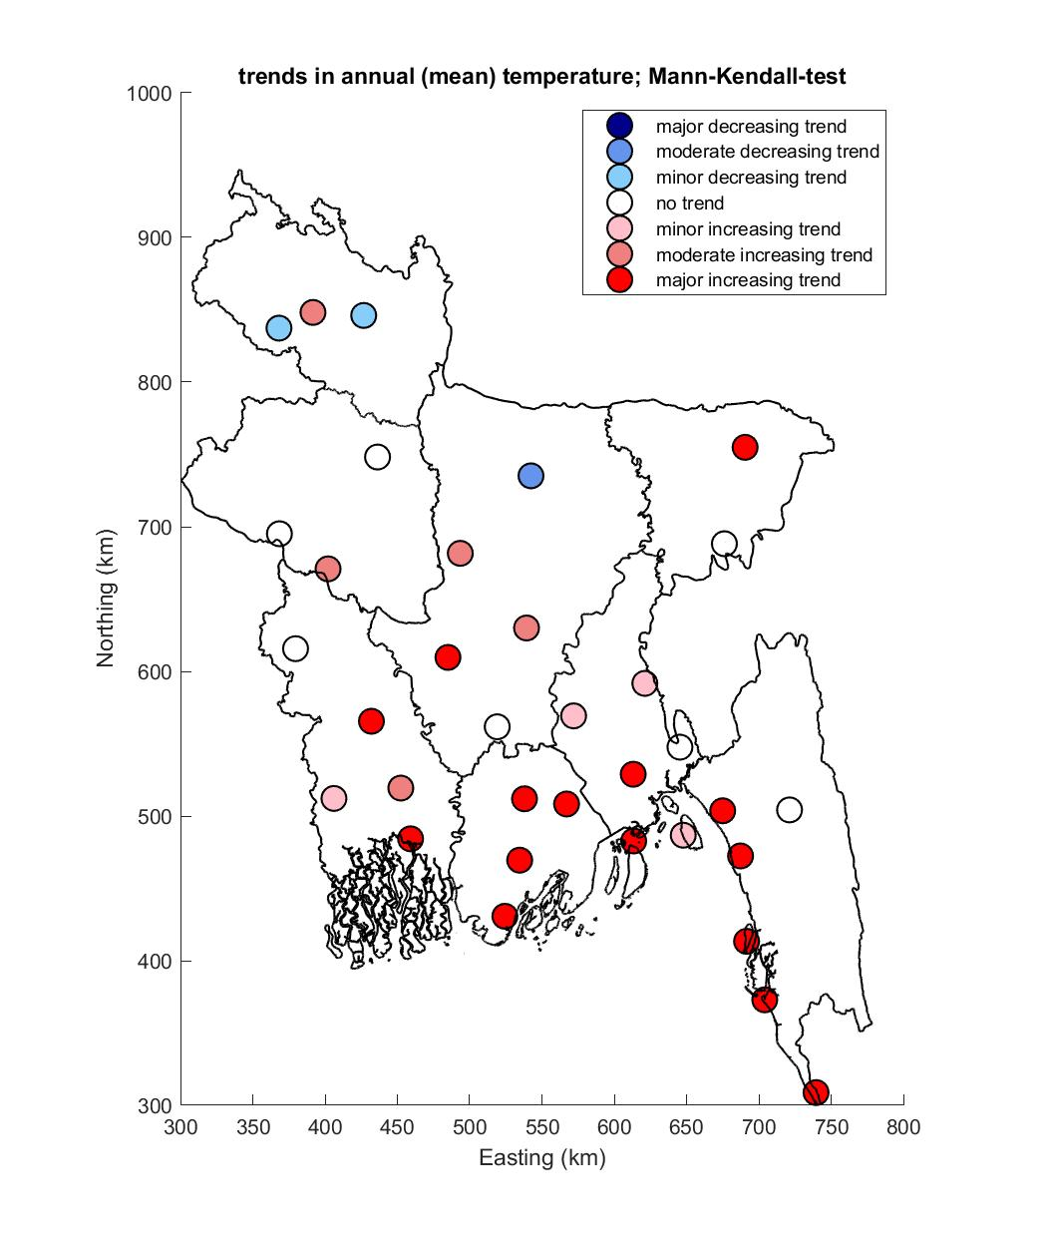

Figure 5.8 Trends in annual mean temperature; Mann-Kendal test.

Table 5.4 Derived trend classes for temperature the combination of all stations. Results are shown for three indicators, four statistical tests and five different seasons (including the whole year).

|  |  |  |  |  |  |  |  |  |  |  |  |  |
| --- | --- | --- | --- | --- | --- | --- | --- | --- | --- | --- | --- | --- |
| Indicator: | Mean temperature | | | | Maximum daily temperature | | | | Minimum daily temperature | | | |
| test: | PS | MK | SM | WMW | PS | MK | SM | WMW | PS | MK | SM | WMW |
| Year | 3 | 3 | 3 | 2 | 0 | 0 | -1 | 0 | -1 | 0 | -1 | 0 |
| Pre-monsoon | 0 | 0 | 0 | 0 | 0 | 0 | -1 | 0 | 0 | 0 | -1 | 0 |
| Monsoon | 3 | 3 | 3 | 3 | 3 | 3 | 1 | 2 | 1 | 1 | 0 | 2 |
| Post-monsoon | 3 | 3 | 3 | 3 | 3 | 3 | 2 | 3 | 0 | 0 | 0 | 0 |
| Winter | 0 | 0 | 0 | 0 | 0 | 0 | -1 | -1 | -1 | -1 | -2 | 0 |

### Tropical cyclones

Bangladesh is a global hotspot for tropical cyclones and its adverse impacts on society (Dasgupta et al., 2016). For example, between 1960-2004 more than half a million inhabitants of Bangladesh died as a consequence of TCs, primarily due to storm surge (Schultz et al., 2005).

In the current situation, tropical cyclones (TC) generate in the Bay of Bengal, propagate northwards and make landfall in a southwest / northeast direction at Bangladesh (see ). Once on land, the intensity of the TCs decrease due to lack of warm water supplying energy to the TC and increase in land roughness. Generation occurs both during the early summer time period (April, May, June, July) as in the late rainy season period (September, October, November, December; see for more information Dasgupta et al., 2016).

In this study, information on TC events derived from the IBTrACS database (Knapp et al., 2010; Knapp et al. 2018) and specifically from the subset by the Joint Typhoon Warning Center (JTWC) were used as a basis to assess possible historical changes in TC frequency and intensity. In particular, the most recent data starting from 1972 and based on satellite detection, provides more accurate information on both historical tracks and cyclone intensity for the North Indian Ocean (see e.g. Singh (2010)).

At first, we have analysed the probability of TC genesis (a) and termination (b). The probability is in this case estimated as number of events within a 200 km radius and divided by the total number of events. a shows that most TC are generated in the middle of the Bay of Bengal (BoB), west of the Andaman and Nicobar Islands. Once generated, the TCs propagate through the BoB and they make landfall in eastern India, with a hotspot in Andhra Pradesh, and in Bangladesh, with a hotspot in the South East region and Eastern Hill (b). This is consistent with the finding of the literature study by Alam and Dominey-Howes (2015).

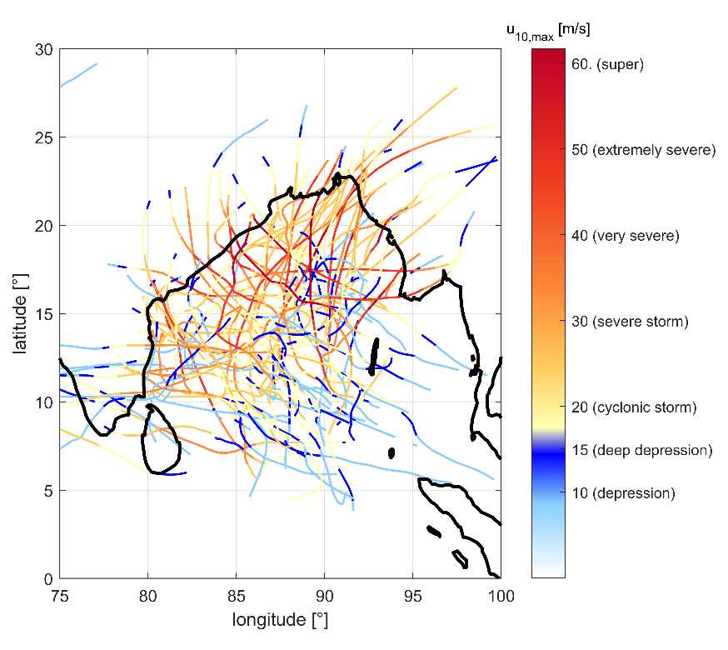

Figure 5.9 Historical tropical cyclone tracks since 1972 as reported in the JTWC database. Indication of the wind speed and severity is provided according to the classification by the India Meteorological Department (IMD) for the North Indian Ocean.

|  |  |
| --- | --- |
| (a) | (b) |

Figure 5.10 Probabilities of genesis (a) and termination (b) for historical tropical cyclones since 1972. Data retrieved from the JTWC database.

Based on the historical tracks, the yearly probability of TC activity was also determined per grid cell (). In this case, the probability was estimated by adding the number of TCs within a 200 km radius and diving by the number of years of observation. The figure shows how, in general, the yearly probability is below one, meaning that it is unlikely that a cell is hit by a cyclone more than once per year. In fact, the value is approximately once in three years in the region of Bangladesh (value of ≈ 0.3).

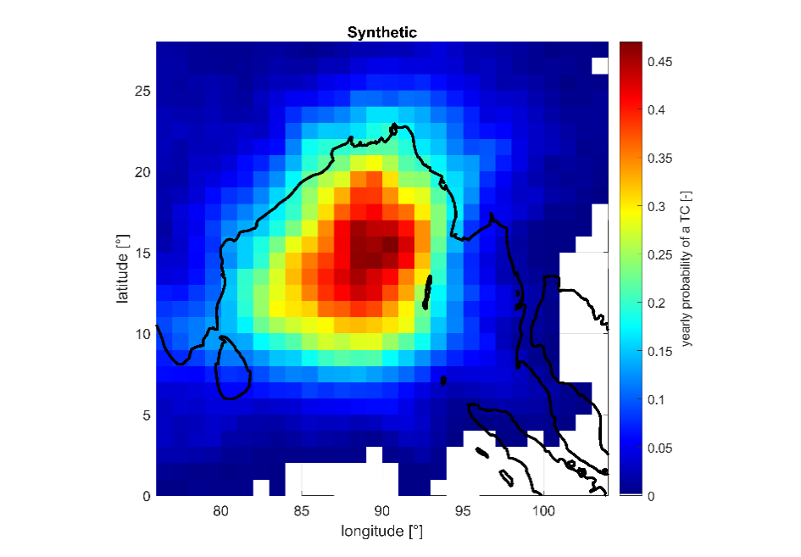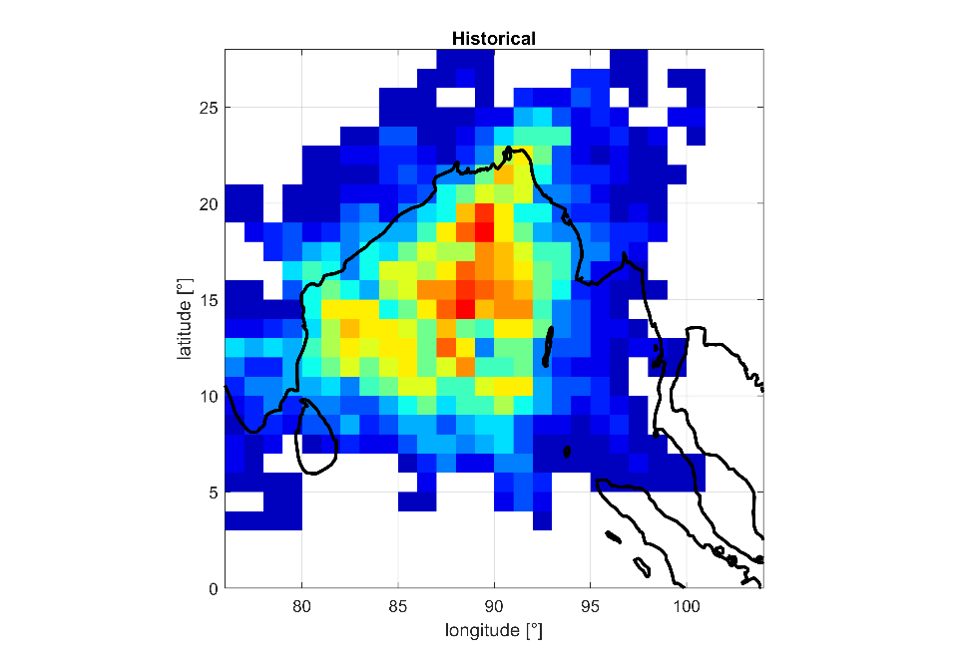

Figure 5.11 Yearly probability of historical TC since 1972. Data retrieved from the JTWC database.

Following the same methodology, the probability of TC generation per month was also plotted in . The Figure shows how TCs are mostly generated in the pre-monsoon period (May) and post-monsoon period (November), which is consistent to literature (see e.g. Alam et al. (2003), Islam et al. (2009) and Dasgupta et al. (2016)).

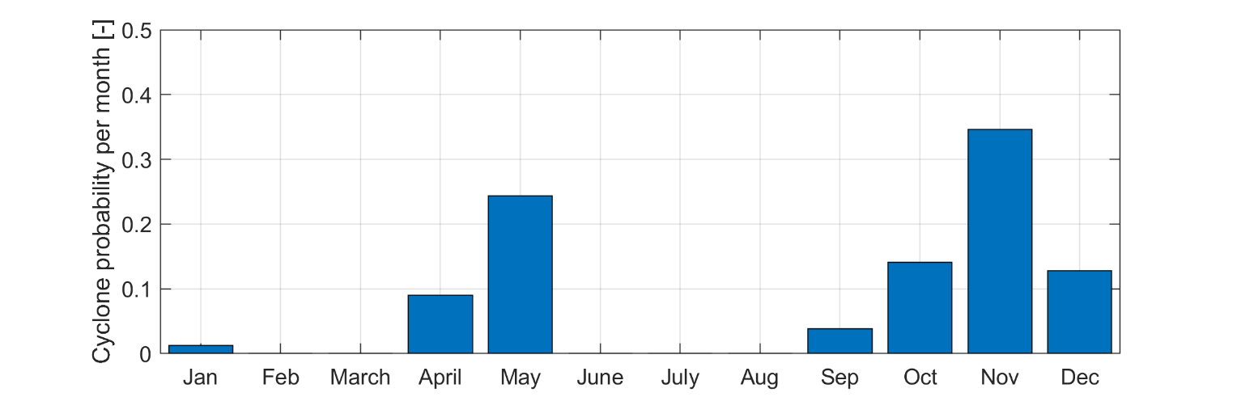

Figure 5.12 Monthly probability of TC generation in the Bay of Bengal based on historical cyclones since 1972. Data retrieved from the JTWC database.

Based on the information from these historical TC from 1972, possible changes in frequency were analysed for the entire Indian Ocean (a), the Bay of Bengal (b) and the Bangladesh coastal zone (c). The three regions are visualized in . Different colours in the figure indicate the TC occurrence when taking into account all cyclone events (blue bars) and most extreme TC only, characterized by a maximum wind speed larger than 40 m/s. Trend lines have also been added to depict possible trends for both cases. However, it is important to stress that it is hard to define actual trend lines due to the very limited number of years of observations. For example, these trend lines are very sensitive to one additional year characterized by a larger or lower number of TC.

a suggests that the number of cyclone events and most extreme cyclone events has been slowly increasing through time during the last 5 decades in the North Indian Ocean. Very remarkable has been the year 2019, which was characterized by 6 TCs, all of them in the “severe” category. The increase has been roughly equal to +0.6% and +4.5% per year, respectively for all the TC events and the most extreme ones only. This finding is consistent for example with Singh et al (2000) and Deo et al (2011), which have shown an intensification of the most extreme TCs.

When we focus on the Bay of Bengal only (b), one can see that the number of TCs has been decreasing, however the number of most extreme TCs has been increasing through time. The estimated changes have been equal to -0.4% per year and +1.7% respectively for all the TC events and the most extreme ones only.

Finally, Figure 3c focuses on the Bangladesh coastal zone only. The figure suggests that in the Bangladesh coastal area, both number of cyclones and number of extreme cyclone events have decreased over time. However, as the number of events is so limited, it could be sufficient that, for example, the year 2020 will be characterized by a larger number of TCs that this will result in a change in slope of these trend lines. Therefore, we have decided not to add a trend line in this last figure.

The yearly number of TC is also dependent by additional multi-year processes such as El Niño-Southern Oscillation (ENSO) (Singh et al., 2000; Hoarau et al. 2012).

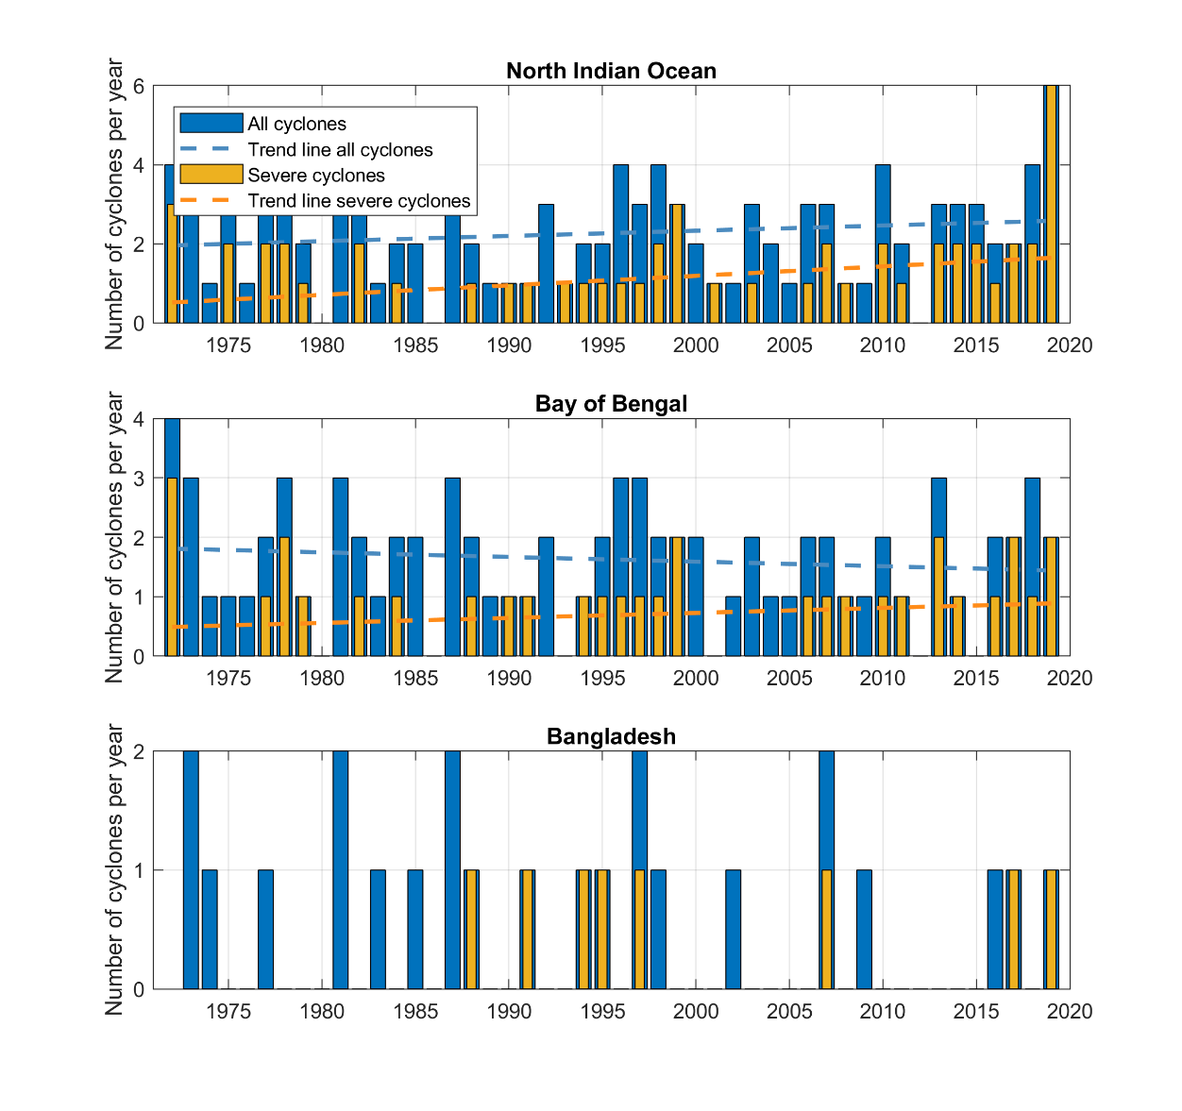

(b)

(c)

(a)

Figure 5.13 Number of cyclones per year since 1972 as retrieved from the JTWC database for: (a) the North Indian Ocean, (b) the Bay of Bengal and (c) the Bangladesh coastal zone. Plots are made for all cyclones (in blue) and only the severe cyclones (maximum wind speed larger than 40 m/s) (in orange). Linear trend lines have been added to show estimated changes in cyclone frequency over the time period.

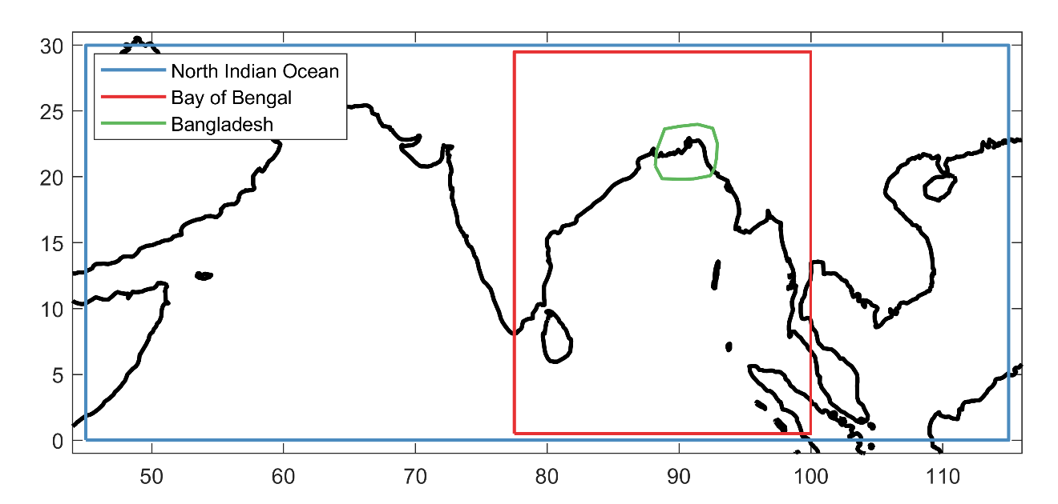

Figure 5.14 Boundaries of the three regions: North Indian Ocean, Bay of Bengal and Bangladesh.

## References

1. Alam, M.A., Hossain, A., and Shafee, S., 2003. Frequency of Bay of Bengal Cyclonic Storms and Depression Crossing Different Coastal Zones. *International Journal of Climatology*. 23, 1119-1125. DOI: 10.1002/joc.927.
2. Alam, E., Dominey-Howes, D., 2014. A new catalogue of tropical cyclones of the northern Bay of Bengal and the distribution and effects of selected landfalling events in Bangladesh. *International Journal of Climatology*. 35, 801-835. DOI: 10.1002/joc.4035.
3. Dasgupta, P., J. F. Morton, D. Dodman, B. Karapinar, F. Meza, M. G. Rivera-Ferre, A. Toure Sarr, and Vincent, K., 2014: Rural areas. *Climate Change 2014: Impacts, Adaptation, and Vulnerability. Part A: Global and Sectoral Aspects. Contribution of Working Group II to the Fifth Assessment Report of the Intergovernmental Panel on Climate Change*. C.B. Field et al., Eds., Cambridge University Press, Cambridge, United Kingdom and New York, NY, USA, 613–657.
4. Deo, A.A., Ganer, D.W., and Nair, G., 2011. Tropical cyclone activity in global warming scenario. *Journal of Natural Hazards*. 59(2), 771-786. 10.1007/s11069-011-9794-8.
5. Hoarau, K., Bernard, J., Chalonge, L., 2011. Review Intense Tropical Cyclone Activities in the Northern Indian Ocean. International Journal of Climatology. 32, 1935-1945. DOI: 10.1002/joc.2406.
6. Islam, T., Peterson, R.E., 2008. Climatology of landfalling tropical cyclones in Bangladesh 1877–2003. *Journal of Natural Hazards*. 48, 115–135 (2009). https://doi.org/10.1007/s11069-008-9252-4.
7. Knapp, K.R., Kruk, M.C., Levinson, D.H., Diamond, H.J., and Neuman, C.J., 2010. *The International Best Track Archive for Climate Stewardship (IBTrACS): Unifying Tropical Cyclone Data*. American Meteorological Society. <https://doi.org/10.1175/2009BAMS2755.1>.
8. Knapp, K.R., Diamond, H.J., Kossin, J.P., Kruk, M.C., Schreck, C.J., 2018. International Best Track Archive for Climate Stewardship (IBTrACS) Project, Version 4. NOAA National Centers for Environmental Information. <https://doi.org/10.25921/82ty-9e16>.
9. MOEF, 2018: Ministry of Environment and Forest Government of the People’s Republic of Bangladesh Climate Change Profile, Report April 2005.
10. Schultz, J.M., Russel, J., and Espinel, Z. 2005. Epidemiology of tropical cyclones: the dynamics of disaster, disease, and development. *Epidemiologic Review* 27, 21-35.
11. Shahid, S., 2009: Rainfall variability and the trends of wet and dry periods in Bangladesh *Int. J. Climatol.* 30: 2299–2313 (2010) DOI: 10.1002/joc.2053.
12. Shahid, S., 2011: Trends in extreme rainfall events of Bangladesh, Theor Appl Climatol (2011) 104:489–499 DOI 10.1007/s00704-010-0363-y.
13. Singh, O. P., Khan, T.M.A., Rahman, S, 2000. Changes in the frequency of tropical cyclones over the North Indian Ocean. *Journal of Meteorology and Atmospheric Physics*. 75, 11-20. <https://doi.org/10.1007/s007030070011>.
14. Singh, O.P., 2010. Recent Trends in Tropical Cyclone Activity in the North Indian Ocean. *Indian Ocean Tropical Cyclones and Climate* Change. 51-54. [10.1007/978-90-481-3109-9_8](https://www.researchgate.net/deref/http%3A%2F%2Fdx.doi.org%2F10.1007%2F978-90-481-3109-9_8?_sg%5B0%5D=eAtQ_SB0lUpx9mf9UnJp5oG4Rim-A2vSihzXLNGLFJXDhif0PEAiVMnEmDeezZyEfSYA9dcX0G_O0dcAyV9h7i9v_g.SnHZ7jlag-zTAgk1Va6q6rIsKtses4gHkDqfD16JHZzaW3xg38Rb-oOb3MPDQF1PWSkN_JmUc9N7eiZW3B3mPg)

# POLDER RECONSTRUCTION PROGRAMME

**This Chapter does not include any progress specific to this Quarter as the work has on request not progressed during Q2 of 2020.**

## Background

Devising a polder reconstruction programme must be based on agreement on a set of clearly enunciated objectives. There is much literature available as project reports on solving problems associated with the Coastal Embankment System over the past 60 years. These reports cover areas of water resources and flood protection, drainage, operation and maintenance of systems, environment, agriculture, fisheries, socio-economic data etc. In more recent times questions of sustainability have begun to play a larger role in design and planning of new systems.

The Coastal Embankment Improvement Programme was initiated in August 2010 as a phased programme of improving the Coastal Embankment System, which had already been in existence for 50 years, to improve its resilience to Climate Change after attention was focussed by two major cyclones, Sidr and Aila, in 2007 and 2009, which caused damage in excess of USD 2 Billion. At that time there were 139 polders protecting the livelihoods of 28 million people from inundation. While it was necessary to protect the embankment system from storm surges originating in the Bay of Bengal which was now recognised as being subject to sea level rise driven by climate change and the lands subject to subsidence, It was clear that the polders would need to be classified in terms of their vulnerability so that a phased improvement programme could be devised to take up the gradual strengthening of the embankment system to resist the impact of climate change and other

17 polders were selected for CEIP-I as the first stage of this project. The selection was done on the basis of a multi-criteria analysis of all 139 polders in 2010. The selection criteria were based on the actual physical attributes of the polder and hydraulic structures and the vulnerability assessment of the respective BWDB Engineers responsible for and possessing intimate knowledge of each polder. The selection of groups of polders for intervention was also influenced by the need to keep the selected polders in groups within close proximity for convenience of access and for determining the design parameters and model boundary conditions.

These 17 polders – now being addressed by the first stages of the CEIP programme, were taken up in 2010 and the designs were based on the knowledge and understanding of physical phenomena and socio-economic development in the coastal zone at that time. Given the much greater and detailed understanding we have of phenomena now and the rapid economic development that had taken place over the past two decades, it is necessary to revisit the analysis of the 139-polder assessment in order to determine the updated priorities for development. It is also necessary to review the design and planning of the first stage of CEIP in the light of the most up-to-date knowledge.

A new data collection campaign has been launched by this project to collect the most up-to-date dataset to revisit the analysis of the 139 polders under the guidance of the international and national experts who have prepared a Road Map for the Investment Plan, illustrated below.

THE ROAD MAP

DATA COLLECTION

ANALYSIS

The updated database for all 139 polders is now available for revisiting the original multicriteria analysis and make revisions based on our latest understanding of phenomena, which have evolved based on new knowledge of matters such as land subsidence, climate change and changes in the catchments in the upper delta. The original selection was based on the data available in the year 2011. The second group of 10 polders selected (but not finalised) for CEIP-2 was also selected in 2012 based mainly on the same dataset.

It is now possible to take full advantage of the Polder Database which has been set up and populated under this project (see Chapter 3) and use it as the principal tool for analysing the properties of the polders into categories suitable for deciding on a strategy for polder reconstruction. The new database has already been expanded to include much more information on demographic, administrative, socio-economic, environmental and other characteristics in order to make it suitable as a tool for devising a reconstruction strategy.

## Selection of 3-5 Polders for Pilot Study

The Terms of Reference demands that three to five “representative polders” were selected to conduct conceptual designs on a pilot basis to also introduce innovative design approaches where appropriate. These pilot polders were to provide additional guidance towards introducing innovative designs to broaden the choices available to the designers. 5 polders were selected after detailed examination of their physical and geographical characteristics after detailed field inspections. The final choice was ratified by the committee convened by the Project Director.

The details of the selection process are given in the Polder Selection Report (2019). These polders are now under detailed study prior to design. Table 6.1 summarises the salient features of the selected polders.

Table 6.1 Five Polders Selected for Pilot Design Study

| Polder Name | District | Coastal region | Key Characteristics |
| --- | --- | --- | --- |
| Polder 15 (CEIP-1) | Satkhira | South-West  Coastal  region | * Very little Freshwater flow from upstream River (Ganges) * Influenced by strong tidal action, salinity problem is acute. * Peripheral river Sedimentation is a major Problem; which creates drainage problem. People inside coastal polder * Experiencing prolonged water logging. * River bank erosion problem |
| Polder 29 Blue  Gold programme | Khulna |
| Polder 40/1 | Barguna | South-Central  Coastal region | * Polder Embankment is facing river Erosion problem. * Vulnerable to cyclonic storm surges. |
| Polder 59/2 | Noakhali | South-East  Coastal region | * Morphologically active land accretion is dominant than erosion. * Severe river erosion due to, thalweg migration. * Vulnerable to cyclonic storm surge. * Some area subjected to prolonged water logging due to encroachment and land reclamation by closing of Tidal creeks. |
| Polders 64/1a & 64/1b | Chittagong | Eastern Hilly region | * Vulnerable to storm surge. * Prone to flash flood due to steep gradient of river and intense rainfall. * Water logging * Erosion around Sangu River |

The five polders selected above have properties that are representative of the polder system and the full range of interventions necessary to provide solutions to identified problems, taking into account their physical characteristics, and their location within the coastal zone. It is felt that a thoughtful approach to the design of these 5 polders will enable the development of approaches that will be useful in for responding to the diverse problems to be overcome within the polder system.

The expanded multi-criteria analysis applied to the polder database, will help us to select a strategy for the staged re-construction of several groups of polders.

During the reporting period the polder management and investment planning team made a field visit to the polders 59/2 and Polder 64/1a and 64/1b, in order to acquit themselves with the problems in the field and discuss with local stakeholders about their day to day problems facing them. Especially the problem of bank erosion in polder 59/2 seems to be a challenging issue. For polder 64/1a and 64/1b different sites with coastal erosion and bank protection works were visited.

The detailed surveys in the five polders selected for pilot studies are presently underway to support the detailed designs. This work in described in Chapter 2.

## Strategic Approach towards devising a Polder Reconstruction Programme

The availability of the new polder database facilitates the re-visiting of the old multicriteria analysis in with the advantage of much more data and detailed knowledge of physical processes that govern their responses of natural hazards.

Table 6.2 shows the additional data types that have to be gathered in order the facilitate the multicriteria analysis. This is Step 1 of the Road Map.

The analysis that precedes the collection of all the data and analyses for preparing the Road Map, the selection of the strategy and the detailed consultations that are required before evolving the investment plan would take a long period of time.

In the selection of possible interventions, meetings were held with the Blue Gold project and two World Bank TA projects on coastal resilience and innovative interventions, in order to use the experiences from these projects. In collaboration with the Blue Gold project the idea of “collaborative design workshops” was proposed. It is proposed to have a test, or pilot, activity with this approach for polder 29. This in order to assess the potential of this approach, especially for the measures within the polder for solutions for change in farming system, TRM and water logging. The approach would also allow for the identification of suggestions for improved polder operation and management activities in which local water management groups could take part.

The polder development plan, once developed, must be subjected to several rounds of consultation with representative groups of stakeholder and finalised thereafter, before the preparation of the Investment Plan.

Table 6.2 Indicators for Polder Data Description

|  |
| --- |
| 1. Sl No |
| 1. **Polder description** |
| 1. **Polder No** |
| 1. **Type of Dyke** |
| 1. **Location of the Polder (Upazila)** |
| 1. **District (Zila)** |
| 1. **Gross Area of the Polder (HA)** |
| 1. **Embankment Length (Km)** |
| 1. **Land use** |
| 1. **Population** |
| 1. **Accessebility** |
| 1. **Production value** |
| 1. **Problem identification** |
| 1. **Breach of Embankment (Km)** |
| 1. **Erosion (Km)** |
| 1. **Requirement of BPW (Km)** |
| 1. **Location in the Risk Zone** |
| 1. **Drainage Congestion (Ha)** |
| 1. **Salinisation** |
| 1. **Subsidence** |
| 1. **Sedimentation** |
| 1. **Climate change** |
| 1. **Flood probability** |
| 1. **Flood risk** |
| 1. **Cyclone probability/risk** |
| 1. **Water quality** |
| 1. **Security** |
| 1. **Environment** |
| 1. **Socio-economic situation** |
| 1. **FSR/lively hoods** |
| 1. **Opportunities** |
| 1. **Innovations** |
| 1. **Polder management** |
| 1. **Raising of polder level** |
| 1. **Land reclamation** |
| 1. **Urban development potential** |
| 1. **Co-financing** |
| 1. **Implementation** |
| 1. **Opinion of Stakeholder** |
| 1. **Rehabilitation Cost  (Crore BDT)** |
| 1. **Economic feasibility** |
| 1. **Climate change component** |
| 1. **Compliance to BDP goals** |
| 1. **Compliance to SDGs** |
| 1. **Resource efficiency** |
| 1. **Flexible** |
| 1. **Robust** |
| 1. **NBS vs Grey infra** |
| 1. **Transfer of problems** |
| 1. **Resilience** |
| 1. **O&M** |
| 1. **Special Criterion** |
| 1. **Remarks** |

## Investment Plan for the Entire CEIP

The preparation of the investment plan which will require identification of potential financing sources and types, and prioritisation and phasing will require that the senior economists and planners in the team should enter into detailed consultations with the client and the possible donors.

# DESIGN PARAMETERS, CONSTRUCTION MANAGEMENT & MONITORING

**The work on revisiting design parameters, construction management and monitoring has on request not progressed during Q2 of 2020.**

1. Designated as Chittagong in Table 4.3